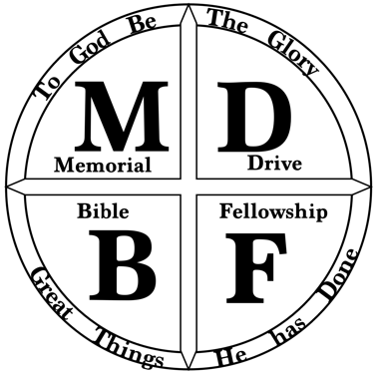
Memorial Drive Bible Fellowship – Youth Pastor Job Description
Our desire is to hire a part-time Youth Pastor who will take over our existing Youth Ministry program and see that our youth continue to be invested in as they grow spiritually. Our prayer is that this person will work with the existing leadership team to disciple the youth and drive the ministry to be a place where teens are able to grow in their relationship with Jesus amidst all the struggles of this world.

Our Expectations of You as the Youth Pastor
- Shepherd the youth through regular teaching from the Word of God at Wednesday night program and Sunday school time
- Pray for and with our youth regularly
- Plan various events beyond the regularly scheduled programs to encourage growth in their faith and fellowship with their peers and church body
- Discern times where extra counseling, confrontation, or mentoring is needed and support our teens through those times
- Exercise wisdom as to when to bring matters to the attention of the lead pastor and/or the parents of the teens
- Develop a discipleship track and/or a youth leadership team for those teens willing to be stretched in their faith beyond regular programing
- Be intentional about developing a relationship with parents as you support them in training up their child
- Provide outreach opportunities for our youth to practice – and learn the importance of – evangelism
- Maintain the development of and recruiting for the existing adult leadership team
- Maintain good communication including a quarterly events calendar

What You Can Expect at MDBF as the Youth Pastor:
- You will become a part of a unified and stable small-town church
  - 75-100 on a given Sunday
- You will work alongside and be mentored by a young lead pastor
  - with experience in/passion for youth ministry
- You will have a great working relationship with area churches
  - several represented in our youth ministry
- You will lead a talented and enthusiastic group of leaders who desire to support you
  - currently running the ministry as volunteers and desire to continue serving
- You will step into an existing ministry with a long history of impact
  - currently 25-35 youth
- You will have a supportive church family willing to pour into you and support you in your personal growth and in your calling to lead the youth ministry
- You will have a great facility to run the ministry, a kitchen attached to a gym with a newly added multipurpose (youth) room

Youth Pastor Qualifications:
- A male (willing and able to fill pulpit and go through elder training)
- 2 Year Bible degree (required/or in progress)
- Experience in Youth Ministry (preferred)
- Willingness to commit (3 year calling with understanding that God may lead elsewhere)

Other Areas of Responsibility
- Occasional pulpit-fill at the request of the elders
- Participate in elder training for your development
- Assuming responsibilities in general ministries within the church as assigned by elders

Means of Oversight and Accountability
- Monthly meetings with the lead pastor
- Quarterly meetings with the elders
- Availability to meet with parents who may have concerns
- Regular reports given at our quarterly all-church meetings

Other Notes:
- Pay and compensation package will be discussed upon interview
- Other part-time ministries in the area to possibly work full-time in ministry

IF INTERESTED:
Send information to mdbf.pastor@gmail.com to inquire about position

Process: (subject to change)
- Send in info/resume to receive an application
- After our committee has looked over resume and application, Pastor Andrew will call
- After phone interview, a visit for an in-person interview with the committee and a Sunday all-church introduction
- After in-person interview and all church feedback, there will be an installation service

