CHRIST CHURCH
of Exeter

The Second Sunday of Easter
April 16, 2023
8:00 & 10:00 a.m.

Reflections on Today’s Readings
Today the Church completes its three great days of celebrating redemption. Since Maundy Thursday, we have been involved in an extended liturgy which will be brought to its conclusion today.

This is the celebration of the Passover of Christ from death to life. It is also the celebration of our own Passover in Holy Baptism in which “we were buried with Christ in his death and raised with him.”

Throughout the fifty days of Easter, the first reading on Sundays is from the Acts of the Apostles rather than from the Old Testament. These weekly readings from Acts describe the life of the first Christians and their proclamation of Christ’s resurrection. Today we hear a portion of the sermon Peter preached to Cornelius, the first Gentile Christian. The second reading is Paul’s reflection on the meaning of the resurrection. Jesus has won out over death. Death is to be destroyed.

The Gospel reading is the account of the women at the tomb and Jesus’ appearance to Mary Magdalene.

As we rejoice in our new life in the risen Christ on this day, he comes among us and is made known to us in the breaking of the bread. We, like the women at the tomb and like Peter and the others, are sent forth to tell the world of his resurrection.

Please feel free to join us in this celebration of God’s victory over death. May you find in this gathering the assurance that God is even now raising you to new life.

From The Rite Light: Reflections on the Sunday Readings and Seasons of the Church Year. Copyright © 2009 by Michael W. Merriman. Church Publishing Incorporated, New York.

Welcome to Christ Church: If you are visiting for the first time, please fill out the welcome cards in the pews and hand it to a member of the clergy after the service. Books and resources for children are located on the table near the side left door. Although there are customary postures (such as standing and kneeling) in Episcopal worship, you are invited to be seated at any point, according to your needs and comfort.

Communion: We offer communion in one kind. It should be understood that communion in one kind (bread/wafer only) is sufficient to experience the Real Presence of our Risen Lord.

The Holy Eucharist

[10:00 service]
Prelude Allegro Vivace (from Water Music Suite) G. F. Handel
Aria in F major

Welcome

✠ All stand, as they are able, as the bell tolls.

[10:00 service]
Processional Hymn 192 This joyful Eastertide Vruechten

Presider Alleluia. Christ is risen.
People The Lord is risen indeed. Alleluia.

Presider and People: Almighty God, to you all hearts are open, all desires known, and from you no secrets are hid: Cleanse the thoughts of our hearts by the inspiration of your Holy Spirit, that we may perfectly love you, and worthily magnify your holy Name; through Christ our Lord. Amen.

[8:00 a.m.]

Glory to God in the highest,
and peace to his people on earth.

Lord God, heavenly King,
almighty God and Father,
we worship you, we give you thanks,
we praise you for your glory.

Lord Jesus Christ, only Son of the Father,
Lord God, Lamb of God,
you take away the sin of the world:
have mercy on us;
you are seated at the right hand of the Father:
receive our prayer.

For you alone are the Holy One,
you alone are the Lord,
you alone are the Most High,
Jesus Christ,
with the Holy Spirit,
in the glory of God the Father. Amen.

[10:00] Gloria S-280

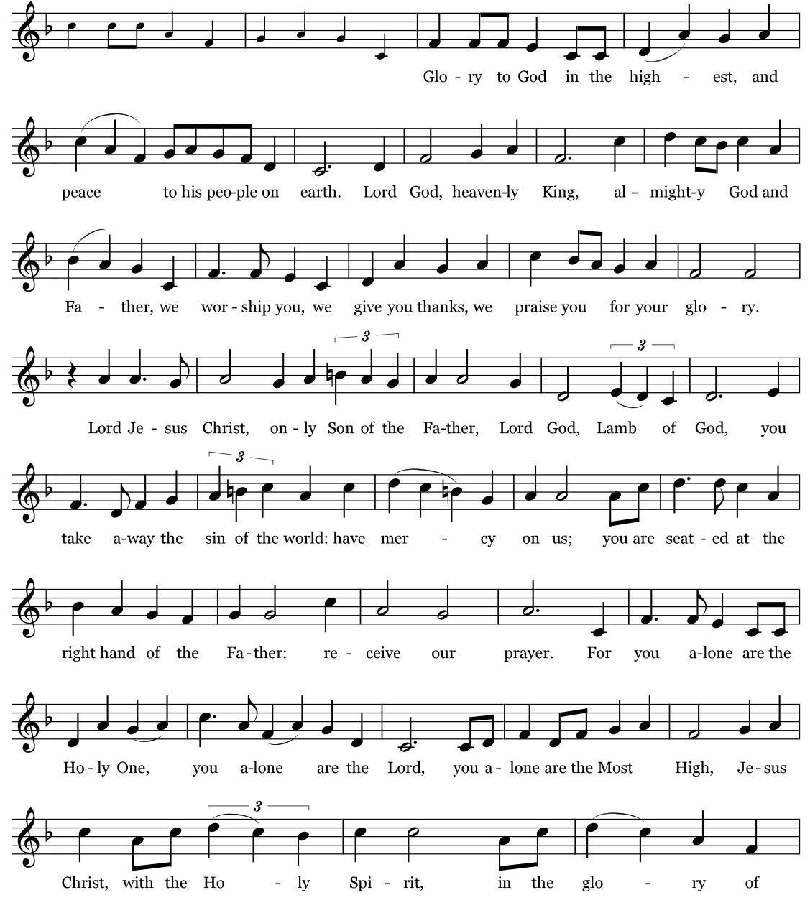
Music: Robert J. Powell © 1985 – Church Publications. All rights reserved. Reprinted under One License.net A700244.

The Collect of the Day

Presider The Lord be with you.
People And also with you.
Presider Let us pray.

Almighty and everlasting God, who in the Paschal mystery established the new covenant of reconciliation: Grant that all who have been reborn into the fellowship of Christ's Body may show forth in their lives what they profess by their faith; through Jesus Christ our Lord, who lives and reigns with you and the Holy Spirit, one God, for ever and ever. Amen.

✠ The people sit.

The First Reading Acts 2:14a, 22-32
Reader A Reading from the Book of Acts

Peter, standing with the eleven, raised his voice and addressed the crowd, “You that are Israelites, listen to what I have to say: Jesus of Nazareth, a man attested to you by God with deeds of power, wonders, and signs that God did through him among you, as you yourselves know— this man, handed over to you according to the definite plan and foreknowledge of God, you crucified and killed by the hands of those outside the law. But God raised him up, having freed him from death, because it was impossible for him to be held in its power. For David says concerning him, ‘I saw the Lord always before me,
for he is at my right hand so that I will not be shaken; therefore my heart was glad, and my tongue rejoiced; moreover my flesh will live in hope. For you will not abandon my soul to Hades, or let your Holy One experience corruption. You have made known to me the ways of life; you will make me full of gladness with your presence.’ “Fellow Israelites, I may say to you confidently of our ancestor David that he both died and was buried, and his tomb is with us to this day. Since he was a prophet, he knew that God had sworn with an oath to him that he would put one of his descendants on his throne. Foreseeing this, David spoke of the resurrection of the Messiah, saying, ‘He was not abandoned to Hades, nor did his flesh experience corruption.’ This Jesus God raised up, and of that all of us are witnesses.”

Reader The Word of the Lord.
People Thanks be to God.

Psalm 16 pg 599 in BCP (read responsively by verse)

1 Protect me, O God, for I take refuge in you; *
I have said to the Lord, "You are my Lord, my good above all other."

2 All my delight is upon the godly that are in the land, *
upon those who are noble among the people.

3 But those who run after other gods *
shall have their troubles multiplied.

4 Their libations of blood I will not offer, *
nor take the names of their gods upon my lips.

5 O Lord, you are my portion and my cup; *
it is you who uphold my lot.

6 My boundaries enclose a pleasant land; *
indeed, I have a goodly heritage.

7 I will bless the Lord who gives me counsel; *
my heart teaches me, night after night.

8 I have set the Lord always before me; *
because he is at my right hand I shall not fall.

9 My heart, therefore, is glad, and my spirit rejoices; *
my body also shall rest in hope.

10 For you will not abandon me to the grave, *
nor let your holy one see the Pit.

11 You will show me the path of life; *
in your presence there is fullness of joy, and in your right hand are pleasures for evermore.

The Second Reading 1 Peter 1:3-9
Reader A Reading from the First Letter of Peter
Blessed be the God and Father of our Lord Jesus Christ! By his great mercy he has given us a new birth into a living hope through the resurrection of Jesus Christ from the dead, and into an inheritance that is imperishable, undefiled, and unfading, kept in heaven for you, who are being protected by the power of God through faith for a salvation ready to be revealed in the last time. In this you rejoice, even if now for a little while you have had to suffer various trials, so that the genuineness of your faith-- being more precious than gold that, though perishable, is tested by fire-- may be found to result in praise and glory and honor when Jesus Christ is revealed. Although you have not seen him, you love him; and even though you do not see him now, you believe in him and rejoice with an indescribable and glorious joy, for you are receiving the outcome of your faith, the salvation of your souls.

People The Word of the Lord.
Reader Thanks be to God.

✠ The people stand as they are able.

[10:00 service]
Sequence Hymn 209 We walk by faith, and not by sight St. Botolph

The Gospel John 20:19-31
Gospeler The Holy Gospel of our Lord Jesus Christ according to John
People Glory to you, Lord Christ.
When it was evening on that day, the first day of the week, and the doors of the house where the disciples had met were locked for fear of the Jews, Jesus came and stood among them and said, "Peace be with you." After he said this, he showed them his hands and his side. Then the disciples rejoiced when they saw the Lord. Jesus said to them again, "Peace be with you. As the Father has sent me, so I send you." When he had said this, he breathed on them and said to them, "Receive the Holy Spirit. If you forgive the sins of any, they are forgiven them; if you retain the sins of any, they are retained." But Thomas (who was called the Twin), one of the twelve, was not with them when Jesus came. So the other disciples told him, "We have seen the Lord." But he said to them, "Unless I see the mark of the nails in his hands, and put my finger in the mark of the nails and my hand in his side, I will not believe." A week later his disciples were again in the house, and Thomas was with them. Although the doors were shut, Jesus came and stood among them and said, "Peace be with you." Then he said to Thomas, "Put your finger here and see my hands. Reach out your hand and put it in my side. Do not doubt but believe." Thomas answered him, "My Lord and my God!" Jesus said to him, "Have you believed because you have seen me? Blessed are those who have not seen and yet have come to believe." Now Jesus did many other signs in the presence of his disciples, which are not written in this book. But these are written so that you may come to believe that Jesus is the Messiah, the Son of God, and that through believing you may have life in his name.

Gospeler ✠ The people sit.The Gospel of the Lord.
People Praise to you, Lord Christ.

Homily The Rev. Melissa Remington

✠ A brief period of silence follows the sermon.

The Nicene Creed (said together)

We believe in one God,
the Father, the Almighty,
maker of heaven and earth,
of all that is, seen and unseen.

We believe in one Lord, Jesus Christ,
the only Son of God,
eternally begotten of the Father,
God from God, Light from Light,
true God from true God,
begotten, not made,
of one Being with the Father.
Through him all things were made.
For us and for our salvation
he came down from heaven:
by the power of the Holy Spirit
he became incarnate from the Virgin Mary,
and was made man.
For our sake he was crucified under Pontius Pilate;
he suffered death and was buried.
On the third day he rose again
in accordance with the Scriptures;
he ascended into heaven
and is seated at the right hand of the Father.
He will come again in glory to judge the living and the dead,
and his kingdom will have no end.

We believe in the Holy Spirit, the Lord, the giver of life,
who proceeds from the Father and the Son.
With the Father and the Son he is worshiped and glorified.
He has spoken through the Prophets.
We believe in one holy catholic and apostolic Church.
We acknowledge one baptism for the forgiveness of sins.
We look for the resurrection of the dead,
and the life of the world to come. Amen.

The Prayers of the People

Please Stand or Kneel

Let us pray to the Lord, saying, “Our Lord and our God, have mercy on us.”
Lord Jesus Christ, you have given your Church the gift of your Holy Spirit. May that same Spirit comfort and strengthen us as we proclaim your resurrection to the world.
Silence
Our Lord and our God,
Have mercy on us.

God of wisdom, teach and counsel the leaders of the nations. May this world be filled with justice and peace.
Silence
Our Lord and our God,
Have mercy on us.

God our provider, you have given us this earth as our island home. May we use its resources wisely and always according to your purpose.

Our Lord and our God,
Have mercy on us.

All-knowing God, raise up for this community people who will stand and voice your truth. May we be led by you on good paths of life.
Silence
Our Lord and our God,
Have mercy on us.

Merciful God, you are a strong refuge for those in trouble. Protect all those who suffer various trials. Reveal yourself to those who struggle to believe in you. Make all your people glad by the living hope that is found in you.
Silence

We pray for Maureen, Susan, Deborah, Billie, Lissa, Sue, Cathy, Jerry, Alice, Bob, Eduardo, David, Martha, Bobbi, Pat, Frank.

Take a moment, either silently or aloud, to pray for those known to you.

Silence

Our Lord and our God,
Have mercy on us.

God of Life, may the dying and the dead rest in hope. Give us faith that you do not abandon anyone—even to the grave. And preserve us for the great inheritance you give us through the resurrection of your Son from the dead. We remember those who have died.
Silence
Our Lord and our God,
Have mercy on us.

Silence

Presider: O Lord our God, accept the fervent prayers of your people; in the multitude of your mercies, look with compassion upon us and all who turn to you for help; for you are gracious, O lover of souls, and to you we give glory, Father, Son, and Holy Spirit, now and for ever. Amen.

✠ The Confession is omitted during the Great Fifty Days of Easter.

The Peace

Presider The peace of the Lord be always with you.
People And also with you.

✠ The people greet one another in the name of the Lord. The Peace may be expressed by shaking hands, bowing, “fist or elbow bumps”, namaste greeting, putting hand over heart, waving, making the peace sign, and by offering a smile.

The Holy Communion

[8:00 service at the Presentation of the Gifts]

Presider All things come of thee, O Lord.
People And of thine own have we given thee. Amen.

[10:00 service]

✠ The people stand for the hymn as they are able.

Offertory Hymn 212 Awake, arise, lift up your voice Richmond

The Great Thanksgiving

Presider The Lord be with you.
People And also with you.
Presider Lift up your hearts.
People We lift them to the Lord.
Presider Let us give thanks to the Lord our God.
People It is right to give God thanks and praise.

The Presider continues
It is right, and a good and joyful thing, always and everywhere to give thanks to you, Father Almighty, Creator of heaven and earth; but chiefly are we bound to praise you for the glorious resurrection of your Son Jesus Christ our Lord; for he is the true Paschal Lamb, who was sacrificed for us, and has taken away the sin of the world. By his death he has destroyed death, and by his rising to life again he has won for us everlasting life.

Therefore we praise you, joining our voices with Angels and Archangels and with all the company of heaven, who for ever sing this hymn to proclaim the glory of your Name:

[8:00 a.m.] Presider and People
Holy, holy, holy Lord, God of power and might,
heaven and earth are full of your glory.
Hosanna in the highest.
Blessed is the one who comes in the name of the Lord.
Hosanna in the highest.

[10:00] Sanctus S-127
Setting: Calvin Hampton © 1984, 1985, 2010, GIA Publications, Inc. All rights reserved. Reprinted under One License.net A700244.

✠ The people kneel or stand as they are able.

The Presider continues
Holy and gracious Father: In your infinite love you made us for yourself; and, when we had fallen into sin and become subject to evil and death, you, in your mercy, sent Jesus Christ, your only and eternal Son, to share our human nature, to live and die as one of us, to reconcile us to you, the God and Father of all. He stretched out his arms upon the cross, and offered himself in obedience to your will, a perfect sacrifice for the whole world.

On the night he was handed over to suffering and death, our Lord Jesus Christ took bread; and when he had given thanks to you, he broke it, and gave it to his disciples, and said, “Take, eat: This is my Body, which is given for you. Do this for the remembrance of me.”

After supper he took the cup of wine; and when he had given thanks, he gave it to them, and said, “Drink this, all of you: This is my Blood of the new Covenant, which is shed for you and for many for the forgiveness of sins. Whenever you drink it, do this for the remembrance of me.”

Therefore we proclaim the mystery of faith:

Presider and People
Christ has died.
Christ is risen.
Christ will come again.

The Presider continues
We celebrate the memorial of our redemption, O Father, in this sacrifice of praise and thanksgiving. Recalling his death, resurrection, and ascension, we offer you these gifts. Sanctify them by your Holy Spirit to be for your people the Body and Blood of your Son, the holy food and drink of new and unending life in him. Sanctify us also that we may faithfully receive this holy Sacrament, and serve you in unity, constancy, and peace; and at the last day bring us with all your saints into the joy of your eternal kingdom.

All this we ask through your Son Jesus Christ. By him, and with him, and in him, in the unity of the Holy Spirit all honor and glory is yours, Almighty Father, now and for ever. AMEN.

The Presider then continues
And now, as our Savior Christ has taught us, we are bold to say,

People and Presider
Our Father, who art in heaven, hallowed be thy Name, thy kingdom come, thy will be done, on earth as it is in heaven. Give us this day our daily bread. And forgive us our trespasses, as we forgive those who trespass against us. And lead us not into temptation, but deliver us from evil. For thine is the kingdom, and the power, and the glory,
for ever and ever. Amen.

The Breaking of the Bread

✠ A period of silence is kept.

[8:00]
Alleluia. Christ our Passover is sacrificed for us;
Therefore let us keep the feast. Alleluia.

[10:00]
Fraction Anthem

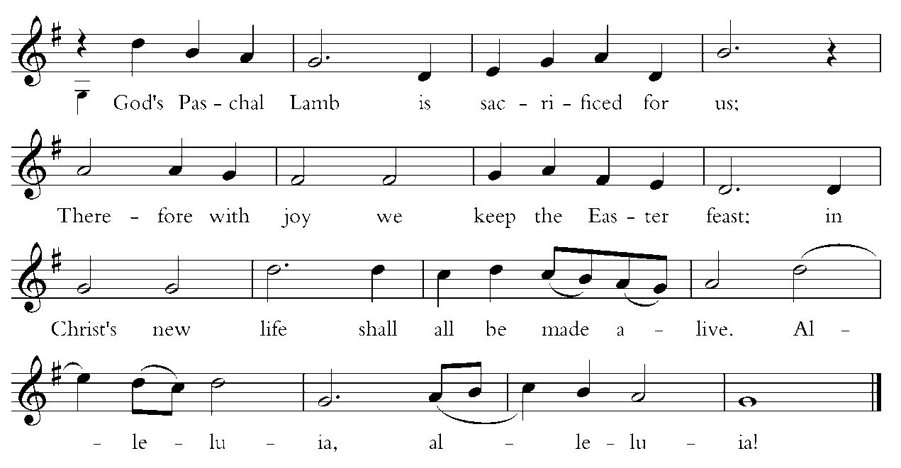
Words by Carl P. Daw, Jr. © 1987, Hope Publishing Company. All rights reserved. Used by permission. One License.net A700244.

Invitation to Communion

The gifts of God for the people of God. Take them in remembrance that Christ died for you, and feed on him in your hearts by faith, with thanksgiving.

Instructions Concerning Communion and Healing

You are invited to receive Holy Communion. Following the usher’s instructions, we begin with those seated in the side sections, starting with the front pews. Please go to the back of the church and proceed down the center aisle to the communion rail. Return to your seat using the outside aisles of those sections. Those seated in the center sections, please come forward beginning with the back pews using the center aisle and return using the diagonal aisles.

Communion may be received kneeling or standing at the altar rails. The bread is received in the open palm. (Gluten-free wafers are available). You may drink from the cup, or place your hand on the base as a sign of devotion. Intinction (dipping the bread/wafer) is not permitted at this time.

Those who do not wish to receive Communion are invited to come forward for a blessing, indicated by crossing your arms over your chest.

Communion can also be brought to you in the pews. Please communicate this request to an usher or the clergy.

The Healing team is available to offer healing prayers at the side of the church. Please tell your healing minister if you have a specific prayer need and if you would like a laying on of hands, just prayers or both.

Communion Music Air (from Water Music Suite) Handel

Post-Communion Prayer

✠ The people kneel or stand as they are able.

Presider and People

Eternal God, heavenly Father,
you have graciously accepted us as living members
of your Son our Savior Jesus Christ,
and you have fed us with spiritual food
in the Sacrament of his Body and Blood.
Send us now into the world in peace,
and grant us strength and courage
to love and serve you
with gladness and singleness of heart;
through Christ our Lord. Amen.

The Blessing

The God of peace, who brought again from the dead our Lord Jesus Christ, the great Shepherd of the sheep, through the blood of the eternal covenant: Make you perfect in every good work to do his will, working in you that which is well-pleasing in his sight; through Jesus Christ, to whom be
glory for ever and ever. Amen.

✠ The people stand as they are able.

[10:00] Recessional Hymn 182, vv. 1-3 Christ is alive! Truro

The Dismissal

Priest Let us go forth in the name of the Risen Christ. Alleluia! Alleluia!
People Thanks be to God. Alleluia! Alleluia!

[10:00] Postlude Hornpipe in F (from Water Music Suite) Handel

The worship is over * The service begins

Participating in Today’s Liturgy:
Preacher/Presider : The Rev. Melissa Remington
Lector at 8:00 a.m.: Becky Moore
Lector at 10:00 a.m.: Lucia Savage
Intercessor at 10:00 a.m.: Katie Simon
Eucharistic Minister at 8:00 a.m.:
Eucharistic Minister at 10:00 a.m.: Jeannette McDonald
Welcome Team/Usher:
Live Streaming Tech:
Altar Guild: Melissa Poirier, Carla Ranks
Hospitality: Kim Billings, Jen Murray, Mary Webber
Flower Delivery: Jeannette McDonald

This week at Christ Church
April 16-22
Sunday | PSP Rehearsal 1:00 p.m.
Monday | Scouts Parents Mtg 6:30 p.m.
Tuesday | Bible Study 11:00 a.m.  PSP Rehearsal 6:00 p.m.  Scouts 6:00 p.m.
Wednesday | Oasis Sisters ZOOM Meeting 10:30 a.m.  PSP Rehearsal 4:00 p.m.  No Choir Rehearsal
Thurs | Gentle Yoga 10:00 a.m.  Pro Musica Rehearsal 5:30 p.m.
The Rector is away on a post Easter Day vacation. Mark returns on April 22. For pastoral emergencies, please contact the Rev. Melissa Remington at (304) 951-0845.

CHRIST CHURCH
43 Pine St., Exeter, NH 03833
Phone: (603) 772-3332 E-mail: office@christchurchexeter.org

Office Hours: Mon, Tue, Thur 9 a.m. - 12 Noon, Weds 9 a.m. - 4 p.m. OFFICE CLOSED FRIDAYS

Rector Ext. 12 [cell phone 860 490-8544]
The Rev. Mark Pendleton mpendleton@christchurchexeter.org

Priest Assoc. for Pastoral care
The Rev. David Holroyd dholroyd@christchurchexeter.org

Priest Associate Ext. 13
The Rev. Melissa Remington mremington@christchurchexeter.org

Interim Director of Music
Suzanne Jalbert Jones musicdirector@christchurchexeter.org

Organist
Bruce Adami bruce@christchurchexeter.org

Administrative assistant Ext. 11
Darla Watt office@christchurchexeter.org

Bookkeeper
Jeannie Madley bookkeeper@christchurch.org

Senior Sexton
George Malgeri ssexton@christchurchexeter.org

Artistic Director of Pine Street Players
Lexi Meunier thepinestreetplayers@gmail.com

Events Coordinator
Christina DeMaio events@christchurchexeter.org

Vestry

Senior Warden Patricia Gianotti
Junior Warden Judy Blaisdell Treasurer Richard Ingram
Clerk John Cofer

Lauri Ayers John Hodsdon Susan Dixon
Christopher Sera Jennifer Murray John Woodard
Morgan McCay Alice Bentley

