CHRIST CHURCH
of Exeter

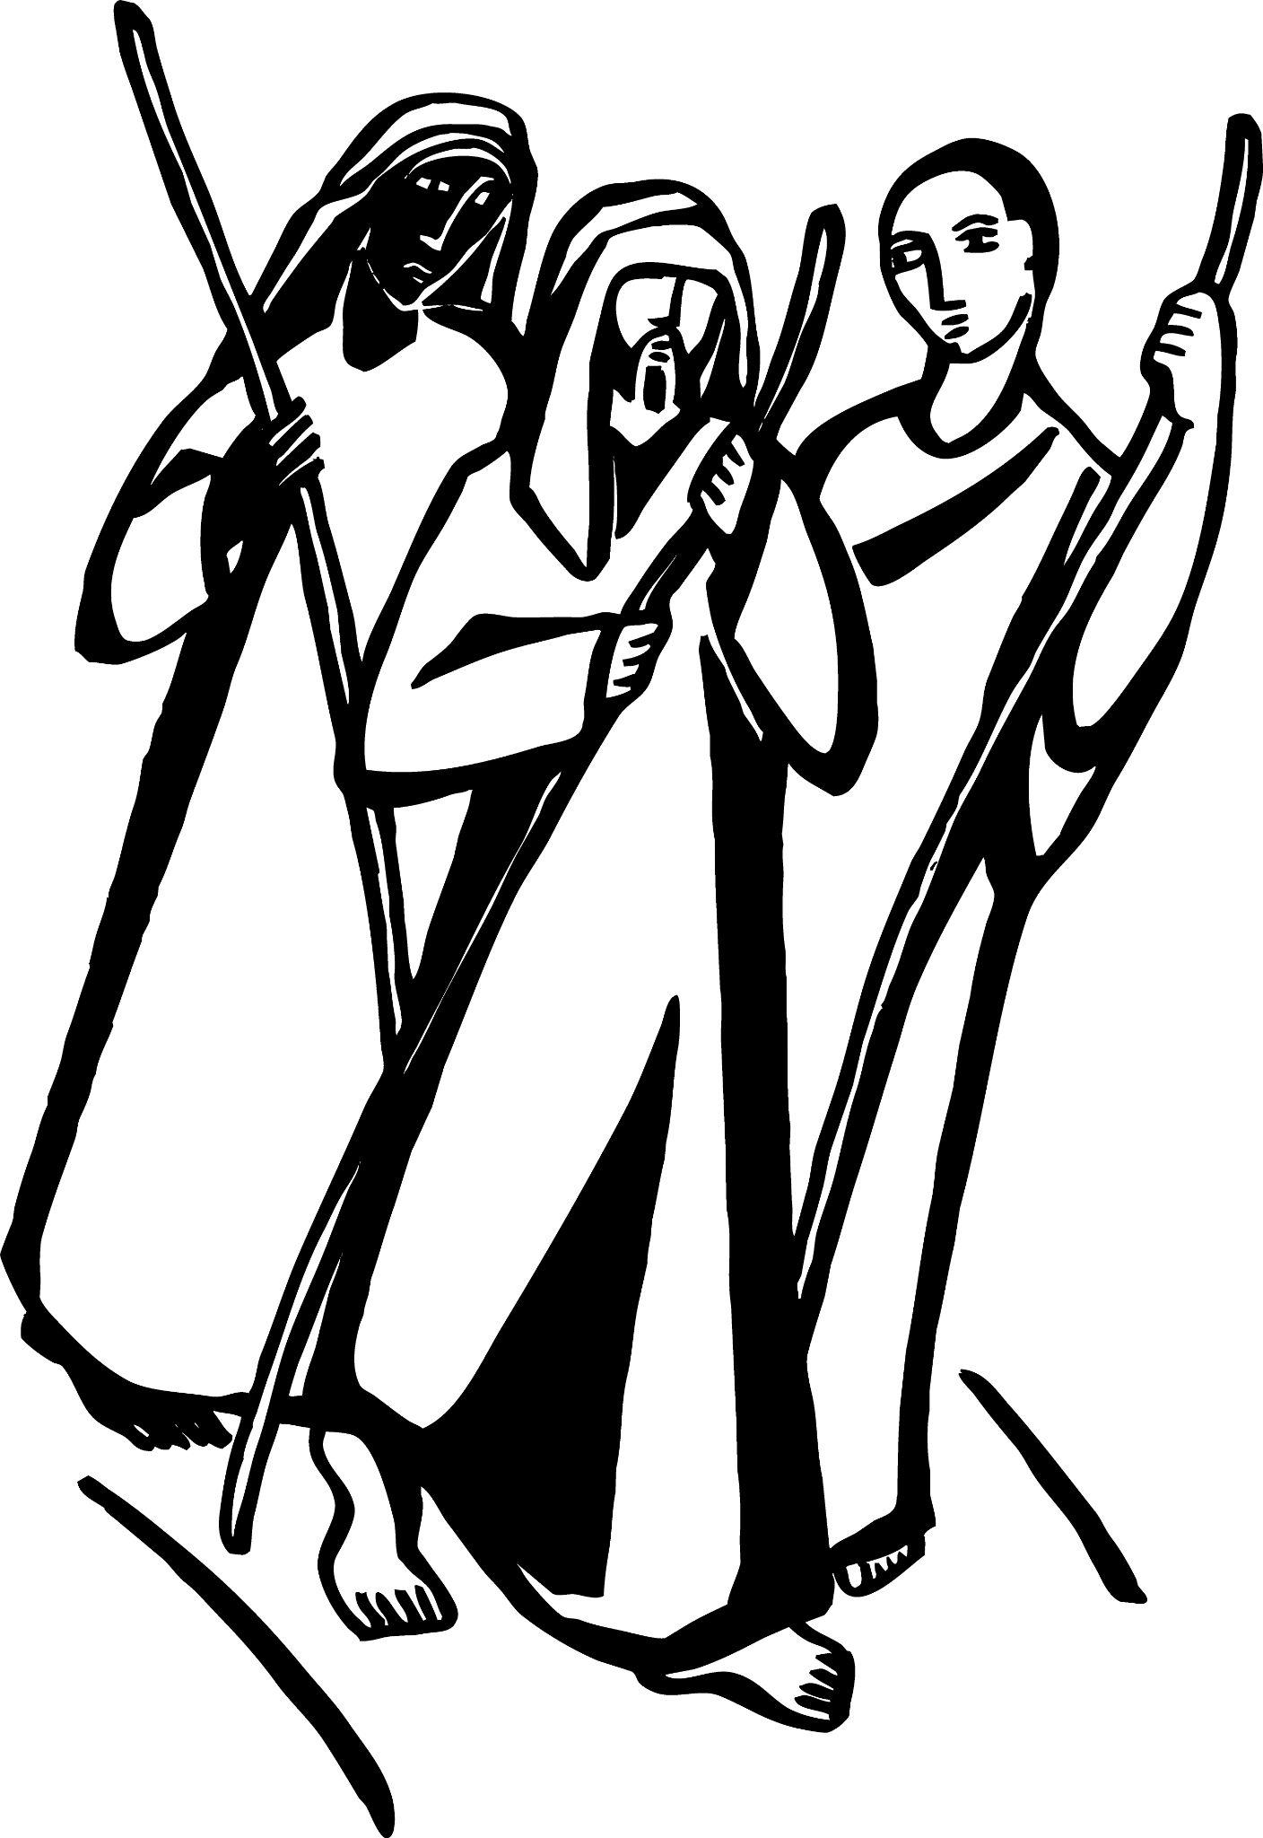

Live
joyfully in faith

Connect
with God and one another

Serve
the local and global community

The Third Sunday of Easter
April 23, 2023
8:00 & 10:00 a.m.

Reflections on Today’s Readings

Each year on this Sunday, the Gospel reading reflects on one aspect of the Lord’s resurrection. Today’s reading is an account of the risen Christ sharing food with his friends. Today we hear about his breaking bread with two disciples who encountered him on their way to Emmaus. Jesus expounded the scriptures to them and at table took bread, said the blessing and broke the bread. It was at that moment that they recognized him.

The first reading continues Peter’s sermon on the first Pentecost day, which we began reading last Sunday. The result of the sermon was a large crowd turning to Jesus as Messiah and being baptized. The church’s way of living and sharing its life is then briefly described.

Today’s reading from 1 Peter continues the letter’s theme: baptism and its results in our lives. We are all new people in the risen Lord and now live in him.

Each Sunday is the resurrection day. For that reason, the church has always made the Eucharist the center of its Sunday worship. As the disciples on the road to Emmaus discovered, Jesus really did rise, and meets us here in the sharing of God’s Word and in the breaking of the bread. As he did on that evening, we take bread, say the blessing, break the bread, and meet the risen Christ.

From The Rite Light: Reflections on the Sunday Readings and Seasons of the Church Year. Copyright © 2009 by Michael W. Merriman. Church Publishing Incorporated, New York.

Welcome to Christ Church: If you are visiting for the first time, please fill out the welcome cards in the pews and hand it to a member of the clergy after the service. Books and resources for children are located on the table near the side left door. Although there are customary postures (such as standing and kneeling) in Episcopal worship, you are invited to be seated at any point, according to your needs and comfort.

Communion: We offer communion in one kind. It should be understood that communion in one kind (bread/wafer only) is sufficient to experience the Real Presence of our Risen Lord.

The Holy Eucharist

[10:00 service]
Prelude Prelude in G major Felix Mendelssohn

Welcome

✠ All stand, as they are able, as the bell tolls.

[10:00 service]
Processional Hymn 495 Hail, thou once despised Jesus! In Babilone

Presider Alleluia. Christ is risen.
People The Lord is risen indeed. Alleluia.

Presider and People: Almighty God, to you all hearts are open, all desires known, and from you no secrets are hid: Cleanse the thoughts of our hearts by the inspiration of your Holy Spirit, that we may perfectly love you, and worthily magnify your holy Name; through Christ our Lord. Amen.

[8:00 service]

Glory to God in the highest,
and peace to his people on earth.

Lord God, heavenly King,
almighty God and Father,
we worship you, we give you thanks,
we praise you for your glory.

Lord Jesus Christ, only Son of the Father,
Lord God, Lamb of God,
you take away the sin of the world:
have mercy on us;
you are seated at the right hand of the Father:
receive our prayer.

For you alone are the Holy One,
you alone are the Lord,
you alone are the Most High,
Jesus Christ,
with the Holy Spirit,
in the glory of God the Father. Amen.

[10:00 service] Gloria S-280

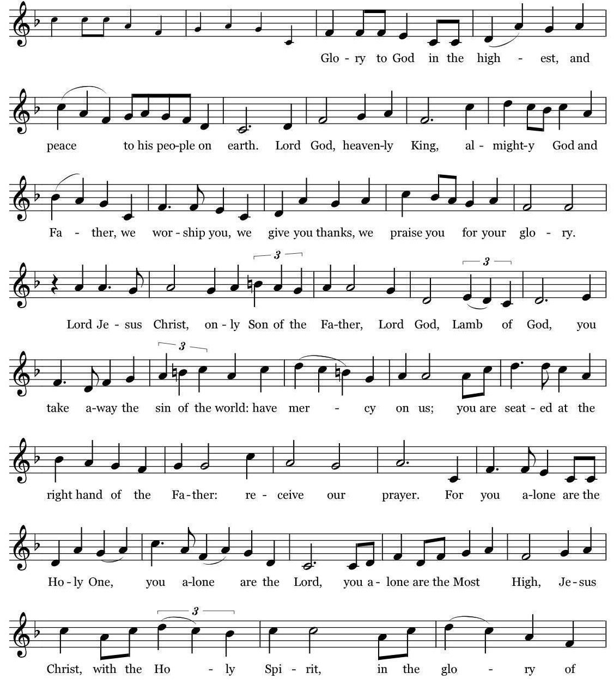
Music: Robert J. Powell © 1985 – Church Publications. All rights reserved. Reprinted under One License.net A700244.

The Collect of the Day

Presider The Lord be with you.
People And also with you.
Presider Let us pray.

O God, whose blessed Son made himself known to his disciples in the breaking of bread: Open the eyes of our faith, that we may behold him in all his redeeming work; who lives and reigns with you, in the unity of the Holy Spirit, one God, now and for ever. Amen.

✠ The people sit.

The First Reading Acts 2:14a, 36-41
Reader A Reading from the Book of Acts
Peter, standing with the eleven, raised his voice and addressed the crowd, “Let the entire house of Israel know with certainty that God has made him both Lord and Messiah, this Jesus whom you crucified.” Now when they heard this, they were cut to the heart and said to Peter and to the other apostles, “Brothers, what should we do?” Peter said to them, “Repent, and be baptized every one of you in the name of Jesus Christ so that your sins may be forgiven; and you will receive the gift of the Holy Spirit. For the promise is for you, for your children, and for all who are far away, everyone whom the Lord our God calls to him.” And he testified with many other arguments and exhorted them, saying, “Save yourselves from this corrupt generation.” So those who welcomed his message were baptized, and that day about three thousand persons were added.

Reader The Word of the Lord.
People Thanks be to God.

Psalm 116:1-3, 10-17 Pg 759 (read responsively by verse)

1 I love the Lord, because he has heard the voice of my supplication, *
because he has inclined his ear to me whenever I called upon him.

2 The cords of death entangled me; the grip of the grave took hold of me; *
I came to grief and sorrow.

3 Then I called upon the Name of the Lord: *
"O Lord, I pray you, save my life."

10 How shall I repay the Lord *
for all the good things he has done for me?

11 I will lift up the cup of salvation *
and call upon the Name of the Lord.

12 I will fulfill my vows to the Lord *
in the presence of all his people.

13 Precious in the sight of the Lord *
is the death of his servants.

14 O Lord, I am your servant; *
I am your servant and the child of your handmaid; you have freed me from my bonds.
15 I will offer you the sacrifice of thanksgiving *
and call upon the Name of the Lord.

16 I will fulfill my vows to the Lord *
in the presence of all his people.

17 In the courts of the Lord'S house, *
in the midst of you, O Jerusalem. Hallelujah!

The Second Reading 1 Peter 1:17-23
Reader A Reading from the First Letter of Peter
If you invoke as Father the one who judges all people impartially according to their deeds, live in reverent fear during the time of your exile. You know that you were ransomed from the futile ways inherited from your ancestors, not with perishable things like silver or gold, but with the precious blood of Christ, like that of a lamb without defect or blemish. He was destined before the foundation of the world, but was revealed at the end of the ages for your sake. Through him you have come to trust in God, who raised him from the dead and gave him glory, so that your faith and hope are set on God. Now that you have purified your souls by your obedience to the truth so that you have genuine mutual love, love one another deeply from the heart. You have been born anew, not of perishable but of imperishable seed, through the living and enduring word of God.

People The Word of the Lord.
Reader Thanks be to God.

✠ The people stand as they are able.

[10:00 service]
Sequence Hymn 306 Come, risen Lord Sursum Corda

The Gospel Luke 24:13-35
Gospeler The Holy Gospel of our Lord Jesus Christ according to Luke
People Glory to you, Lord Christ.
Now on that same day two of Jesus' disciples were going to a village called Emmaus, about seven miles from Jerusalem, and talking with each other about all these things that had happened. While they were talking and discussing, Jesus himself came near and went with them, but their eyes were kept from recognizing him. And he said to them, “What are you discussing with each other while you walk along?” They stood still, looking sad. Then one of them, whose name was Cleopas, answered him, “Are you the only stranger in Jerusalem who does not know the things that have taken place there in these days?” He asked them, “What things?” They replied, “The things about Jesus of Nazareth, who was a prophet mighty in deed and word before God and all the people, and how our chief priests and leaders handed him over to be condemned to death and crucified him. But we had hoped that he was the one to redeem Israel. Yes, and besides all this, it is now the third day since these things took place. Moreover, some women of our group astounded us. They were at the tomb early this morning, and when they did not find his body there, they came back and told us that they had indeed seen a vision of angels who said that he was alive. Some of those who were with us went to the tomb and found it just as the women had said; but they did not see him.” Then he said to them, “Oh, how foolish you are, and how slow of heart to believe all that the prophets have declared! Was it not necessary that the Messiah should suffer these things and then enter into his glory?” Then beginning with Moses and all the prophets, he interpreted to them the things about himself in all the scriptures.
As they came near the village to which they were going, he walked ahead as if he were going on. But they urged him strongly, saying, “Stay with us, because it is almost evening and the day is now nearly over.” So he went in to stay with them. When he was at the table with them, he took bread, blessed and broke it, and gave it to them. Then their eyes were opened, and they recognized him; and he vanished from their sight. They said to each other, “Were not our hearts burning within us while he was talking to us on the road, while he was opening the scriptures to us?” That same hour they got up and returned to Jerusalem; and they found the eleven and their companions gathered together. They were saying, “The Lord has risen indeed, and he has appeared to Simon!” Then they told what had happened on the road, and how he had been made known to them in the breaking of the bread.

Gospeler The Gospel of the Lord.
People Praise to you, Lord Christ.

✠ The people sit.

Sermon The Rev. Mark B. Pendleton

✠ A brief period of silence follows the sermon.

The Nicene Creed (said together)

We believe in one God,
the Father, the Almighty,
maker of heaven and earth,
of all that is, seen and unseen.

We believe in one Lord, Jesus Christ,
the only Son of God,
eternally begotten of the Father,
God from God, Light from Light,
true God from true God,
begotten, not made,
of one Being with the Father.
Through him all things were made.
For us and for our salvation
he came down from heaven:
by the power of the Holy Spirit
he became incarnate from the Virgin Mary,
and was made man.
For our sake he was crucified under Pontius Pilate;
he suffered death and was buried.
On the third day he rose again
in accordance with the Scriptures;
he ascended into heaven
and is seated at the right hand of the Father.
He will come again in glory to judge the living and the dead,
and his kingdom will have no end.
We believe in the Holy Spirit, the Lord, the giver of life,
who proceeds from the Father and the Son.
With the Father and the Son he is worshiped and glorified.
He has spoken through the Prophets.
We believe in one holy catholic and apostolic Church.
We acknowledge one baptism for the forgiveness of sins.
We look for the resurrection of the dead,
and the life of the world to come. Amen.

The Prayers of the People

Please Stand or Kneel

Let us offer the prayers of our hearts, saying, “Stay with us, Lord Jesus; hear our prayer.”
Lord Jesus Christ, you have ransomed us by your own precious blood. Once again, as a holy community, we place our faith and hope in you.
Silence
Stay with us, Lord Jesus;
Hear our prayer.

Save us, O Lord, from corruption. Deliver the nations and peoples from greed and hatred. Place in your children hearts of repentance.
Silence
Stay with us, Lord Jesus;
Hear our prayer.

O Lord, you are the giver of good things. We thank you for this planet; we thank you for its gifts. We pray a blessing on the seeds that were sown this spring that the harvest might be bountiful.
Stay with us, Lord Jesus;
Hear our prayer.

O Lord, you are made known in the breaking of bread and so we pray for all those who lack bread. We pray for the hungry. You feed us generously at your table. Help us to generously feed the world.
Silence
Stay with us, Lord Jesus;
Hear our prayer.

Whenever we call upon you, gracious Lord, you incline your ear to us. We raise our voices for those for whom we care: those who are ill, those who are struggling, those who are in need of your mercy.
Stay with us, Lord Jesus;
Hear our prayer.
Precious in your sight, O Lord, is the death of your servants. We trust you with our dead and with our dying. Jesus, be gracious with them, we pray.
Silence
Stay with us, Lord Jesus;
Hear our prayer.

We pray for Othello, Abigail, Linda, Nina, Snookie, Doug, Frank, Deborah, Sue, David, Martha, Bobbi, Pat, Frank.

Take a moment, either silently or aloud, to pray for those known to you.

We remember those who have died … we remember Maureen Hunter who died last week.

Silence

Presider: O Lord our God, accept the fervent prayers of your people; in the multitude of your mercies, look with compassion upon us and all who turn to you for help; for you are gracious, O lover of souls, and to you we give glory, Father, Son, and Holy Spirit, now and for ever. Amen.

✠ The Confession is omitted during the Great Fifty Days of Easter.

The Peace

Presider The peace of the Lord be always with you.
People And also with you.

✠ The people greet one another in the name of the Lord. The Peace may be expressed by shaking hands, bowing, “fist or elbow bumps”, namaste greeting, putting hand over heart, waving, making the peace sign, and by offering a smile.

The Holy Communion

[8:00 service at the Presentation of the Gifts]

Presider All things come of thee, O Lord.
People And of thine own have we given thee. Amen

[10:00 Service]
Offertory Anthem Now Let Us All Praise God and Sing Gordon Young
Christ Church Choir

Text: Now let us all praise God and sing our great Redeemer’s praise;
That we may all with one account our joyful voices raise.
Sing Alleluia!

All ye servants of the Lord, praise Him forever,
Sing Jehovah’s mighty pow’r, praise Him forever.
Sing of his righteousness, praise Him forever.

So let us all praise God and sing our great Redeemer’s praise;
That we may all with one account our joyful voices raise.
Sing Alleluia!

✠ The people stand for the hymn as they are able.

[10:00 service]
Offertory Hymn 204 Now the green blade riseth Noël nouvelet

The Great Thanksgiving

Presider The Lord be with you.
People And also with you.
Presider Lift up your hearts.
People We lift them to the Lord.
Presider Let us give thanks to the Lord our God.
People It is right to give God thanks and praise.

The Presider continues
It is right, and a good and joyful thing, always and everywhere to give thanks to you, Father Almighty, Creator of heaven and earth; but chiefly are we bound to praise you for the glorious resurrection of your Son Jesus Christ our Lord; for he is the true Paschal Lamb, who was sacrificed for us, and has taken away the sin of the world. By his death he has destroyed death, and by his rising to life again he has won for us everlasting life.

Therefore we praise you, joining our voices with Angels and Archangels and with all the company of heaven, who for ever sing this hymn to proclaim the glory of your Name:

[8:00 a.m.] Presider and People
Holy, holy, holy Lord, God of power and might,
heaven and earth are full of your glory.
Hosanna in the highest.
Blessed is the one who comes in the name of the Lord.
Hosanna in the highest.

[10:00 Service] Sanctus S-128
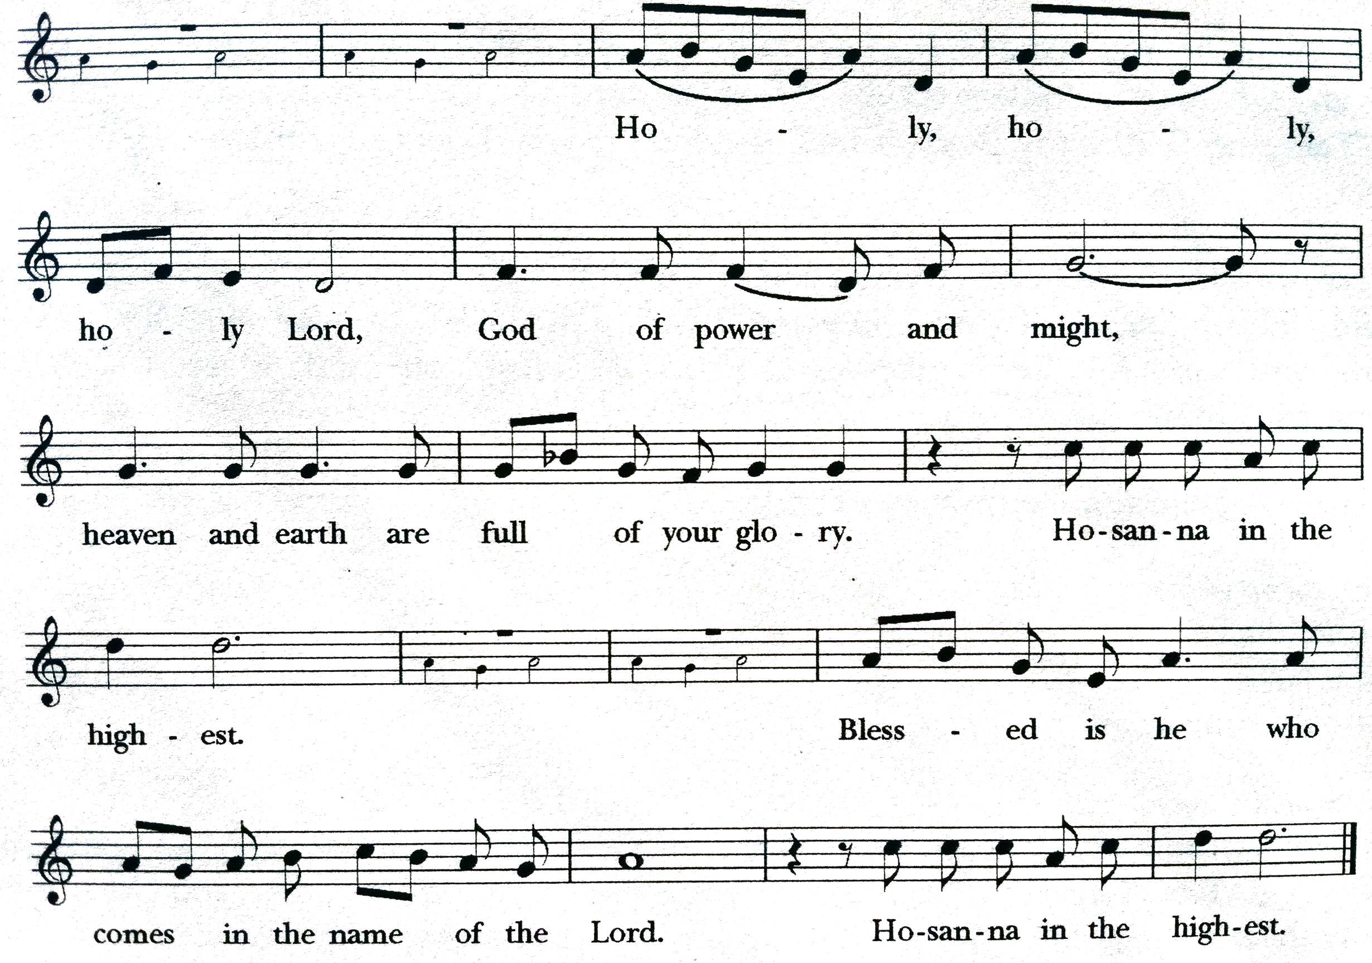
From the Hymnal 1982, © 1985 The Church Pension Fund. All rights reserved. Used by permission of Oxford University Press. One License.net A700244.

✠ The people kneel or stand as they are able.

The Presider continues
Holy and gracious Father: In your infinite love you made us for yourself; and, when we had fallen into sin and become subject to evil and death, you, in your mercy, sent Jesus Christ, your only and eternal Son, to share our human nature, to live and die as one of us, to reconcile us to you, the God and Father of all. He stretched out his arms upon the cross, and offered himself in obedience to your will, a perfect sacrifice for the whole world.

On the night he was handed over to suffering and death, our Lord Jesus Christ took bread; and when he had given thanks to you, he broke it, and gave it to his disciples, and said, “Take, eat: This is my Body, which is given for you. Do this for the remembrance of me.”

After supper he took the cup of wine; and when he had given thanks, he gave it to them, and said, “Drink this, all of you: This is my Blood of the new Covenant, which is shed for you and for many for the forgiveness of sins. Whenever you drink it, do this for the remembrance of me.”

Therefore we proclaim the mystery of faith:

Presider and People
Christ has died.
Christ is risen.
Christ will come again.

The Presider continues
We celebrate the memorial of our redemption, O Father, in this sacrifice of praise and thanksgiving. Recalling his death, resurrection, and ascension, we offer you these gifts. Sanctify them by your Holy Spirit to be for your people the Body and Blood of your Son, the holy food and drink of new and unending life in him. Sanctify us also that we may faithfully receive this holy Sacrament, and serve you in unity, constancy, and peace; and at the last day bring us with all your saints into the joy of your eternal kingdom.

All this we ask through your Son Jesus Christ. By him, and with him, and in him, in the unity of the Holy Spirit all honor and glory is yours, Almighty Father, now and for ever. AMEN.

The Presider then continues
And now, as our Savior Christ has taught us, we are bold to say,

People and Presider
Our Father, who art in heaven, hallowed be thy Name, thy kingdom come, thy will be done, on earth as it is in heaven. Give us this day our daily bread. And forgive us our trespasses, as we forgive those who trespass against us. And lead us not into temptation, but deliver us from evil. For thine is the kingdom, and the power, and the glory,
for ever and ever. Amen.

The Breaking of the Bread

✠ A period of silence is kept.

[8:00]
Alleluia. Christ our Passover is sacrificed for us;
Therefore let us keep the feast. Alleluia.

[10:00 service]
Fraction Anthem

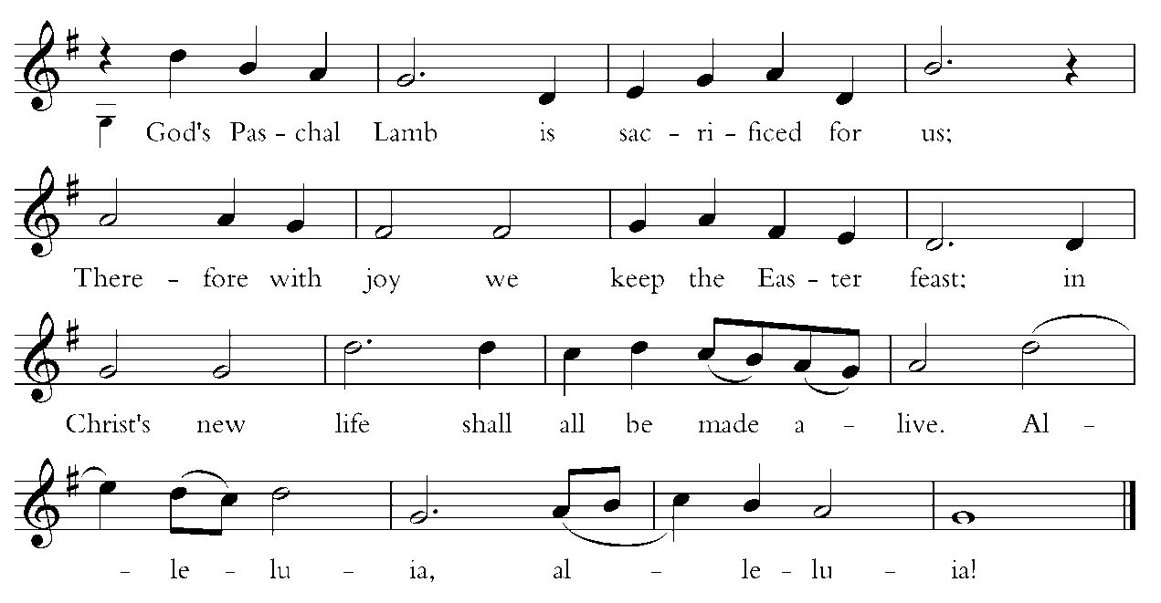

Words by Carl P. Daw, Jr. © 1987, Hope Publishing Company. All rights reserved. Used by permission. One License.net A700244.

Invitation to Communion

The gifts of God for the people of God. Take them in remembrance that Christ died for you, and feed on him in your hearts by faith, with thanksgiving.

Instructions Concerning Communion and Healing

You are invited to receive Holy Communion. Following the usher’s instructions, we begin with those seated in the side sections, starting with the front pews. Please go to the back of the church and proceed down the center aisle to the communion rail. Return to your seat using the outside aisles of those sections. Those seated in the center sections, please come forward beginning with the back pews using the center aisle and return using the diagonal aisles.

Communion may be received kneeling or standing at the altar rails. The bread is received in the open palm. (Gluten-free wafers are available). You may drink from the cup, or place your hand on the base as a sign of devotion. Intinction (dipping the bread/wafer) is not permitted at this time.

Those who do not wish to receive Communion are invited to come forward for a blessing, indicated by crossing your arms over your chest.

Communion can also be brought to you in the pews. Please communicate this request to an usher or the clergy.

The Healing team is available to offer healing prayers at the side of the church. Please tell your healing minister if you have a specific prayer need and if you would like a laying on of hands, just prayers or both.

[10:00 service]
Communion Hymns WLP 764 Taste and see Moore WLP 763 As we gather at your table Raquel

Post-Communion Prayer

✠ The people kneel or stand as they are able.

Presider and People
Eternal God, heavenly Father,
you have graciously accepted us as living members
of your Son our Savior Jesus Christ,
and you have fed us with spiritual food
in the Sacrament of his Body and Blood.
Send us now into the world in peace,
and grant us strength and courage
to love and serve you
with gladness and singleness of heart;
through Christ our Lord. Amen.

The Blessing

✠ The people stand as they are able.

[10:00 service]
Recessional Hymn 205 Good Christians all, rejoice and sing! Gelobt sei Gott

The Dismissal

Priest Let us go forth in the name of the Risen Christ. Alleluia! Alleluia!
People Thanks be to God. Alleluia! Alleluia!

[10:00 service] Postlude Fugue in G major Mendelssohn

The worship is over * The service begins

Participating in Today’s Liturgy:
Preacher/Presider : The Rev. Mark B. Pendleton
Lector at 8:00 a.m.: Cary Einhaus
Lector at 10:00 a.m. Danielle Larson Clark
Intercessor at 10:00 a.m.: John Woodard
Eucharistic Minister at 8:00 a.m.:
Eucharistic Minister at 10:00 a.m.: Laurel Patterson
Welcome Team/Usher:
Live Streaming Tech: Joe DiPalermo
Altar Guild: Priscilla Santiago, Robin Sirois
Hospitality: Adrienne Spear, Toy Fountain
Flower Delivery: Juliette Gavin

This week at Christ Church
April 23-29
Sunday | Forum on Cuba 11:15 a.m.  PSP Rehearsal 1:00 p.m.
Tuesday | Bible Study 11:00 a.m.  PSP Rehearsal 6:00 p.m.  Scouts 6:00 p.m.
Wednesday | Oasis Sisters ZOOM Meeting 10:30 a.m.  PSP Rehearsal 4:00 p.m.
Saturday | Men’s Group 8:00 a.m.

CHRIST CHURCH
43 Pine St., Exeter, NH 03833
Phone: (603) 772-3332 E-mail: office@christchurchexeter.org

Office Hours: Mon, Tue, Thur 9 a.m. - 12 Noon, Weds 9 a.m. - 4 p.m. OFFICE CLOSED FRIDAYS

Rector Ext. 12 [cell phone 860 490-8544]
The Rev. Mark Pendleton mpendleton@christchurchexeter.org

Priest Assoc. for Pastoral care
The Rev. David Holroyd dholroyd@christchurchexeter.org

Priest Associate Ext. 13
The Rev. Melissa Remington mremington@christchurchexeter.org

Interim Director of Music
Suzanne Jalbert Jones musicdirector@christchurchexeter.org

Organist
Bruce Adami bruce@christchurchexeter.org

Administrative assistant Ext. 11
Darla Watt office@christchurchexeter.org

Bookkeeper
Jeannie Madley bookkeeper@christchurch.org

Senior Sexton
George Malgeri ssexton@christchurchexeter.org

Artistic Director of Pine Street Players
Lexi Meunier thepinestreetplayers@gmail.com

Events Coordinator
Christina DeMaio events@christchurchexeter.org

Vestry

Senior Warden Patricia Gianotti
Junior Warden Judy Blaisdell Treasurer Richard Ingram
Clerk John Cofer

Lauri Ayers John Hodsdon Susan Dixon
Christopher Sera Jennifer Murray John Woodard
Morgan McCay Alice Bentley

