**Lebanon United Methodist Church welcomes the Reverend Brian Posey and his family!**

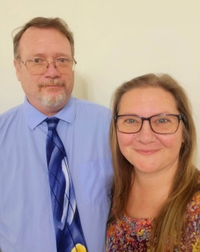Rev. Posey was born and raised in Manassas, Virginia, and was baptized in the United Methodist Church at the age of three months. In 1996 he graduated from what was formerly known as Stonewall Jackson Senior High School in Prince William County, but in 2020 was renamed Unity Reed High School. In 2001 he earned a B.A. in History from Longwood College and planned to pursue to a teaching career. But God intervened, and Brian continued to hear a calling to the ministry. In 2010 he was awarded his Master of Divinity degree from Eastern Mennonite Seminary in Harrisonburg.

Brian’s wife Kara was born in Pennsylvania in 1976, although she spent her early childhood years in Alaska. Her family moved frequently throughout the northwestern United States before eventually settling in Northern Virginia. In 1994, Kara graduated from James Madison High School in Vienna, Virginia.

Brian and Kara met while attending Church at St. Mark’s UMC in Manassas. They married on Valentine’s Day, 2004, a date chosen purposefully so Brian wouldn’t forget his wedding anniversary. Regrettably, the following year Brian forgot their anniversary.

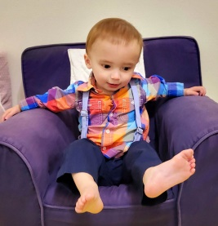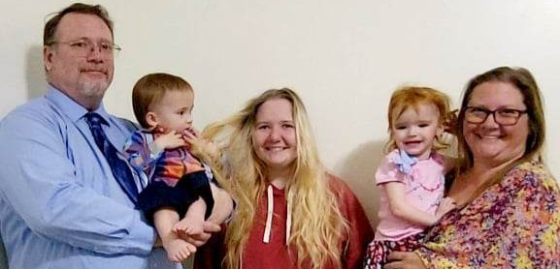Their daughter Madison was born June 18, 2004. Kara homeschooled her, and Madison completed her secondary education at the age of 16. Now 18, she is an amazing artist and has a natural ear for music and playing the piano.

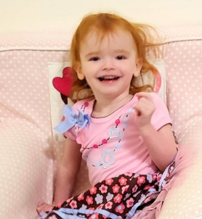On October 1, 2020, Willow Grace Mackey came to live in the custody and care of Brian and Kara. Eleven months and one week later, Willow’s brother John Greyson Mackey entered the world and also came into the custody and care of the Posey family. At that time Kara left her job with Home Instead Senior Care to once again become a stay-at-home mom and devote herself fulltime to the care of little Willow and Greyson.

Pastor Brian, who has been pastoring since 2008, served with the Harrisonburg District for his first two appointments. He was a District Youth Coordinator and the Harrisonburg District Disaster Response Coordinator. For the past three years, Brian has been involved with coordinating the collection of Conference Kits, and for the last four years he has served as the Camp Overlook Board President. Pastor Brian is passionate about missions.