CHRIST CHURCH
of Exeter

Live
joyfully in faith

Connect
with God and one another

Serve
the local and global community

The Sixth Sunday of Easter
May 14, 2023
8:00 & 10:00 a.m.

Reflections on Today’s Readings
As we continue the Great Fifty Days of celebrating our redemption through the death and resurrection of Jesus, today’s Gospel reading continues Jesus’ words on the night before he died. The sign of our love of him is to follow his commandments and, above all, to love one another as he loves us. He promises not to leave his people alone but will send to them the Holy Spirit, the source of our unity with God and of Jesus’ revelation of himself to us.

Today’s reading from the Acts of the Apostles finds Paul preaching not to Jews and Greek converts to Judaism (as he usually did), but to the Greek philosophers in Athens. He proclaims that their unknown god is the God of the entire universe and the creator of all things. This God has been made known in the dying and rising of Jesus.

Peter’s epistle about baptism continues in our second reading calling on all the baptized to understand the difficulties of living in this world as our own sharing in the dying and rising of Jesus.

Our sharing in his redemptive death and in his resurrection was not completed in baptism; it was only begun. We are to live out that passage from death to life with his living presence through the Holy Spirit in our daily living.

From The Rite Light: Reflections on the Sunday Readings and Seasons of the Church Year. Copyright © 2009 by Michael W. Merriman. Church Publishing Incorporated, New York.

Welcome to Christ Church: If you are visiting for the first time, please fill out the welcome cards in the pews and hand it to a member of the clergy after the service. Books and resources for children are located on the table near the side left door. Although there are customary postures (such as standing and kneeling) in Episcopal worship, you are invited to be seated at any point, according to your needs and comfort.

Communion: We offer communion in one kind. It should be understood that communion in one kind (bread/wafer only) is sufficient to experience the Real Presence of our Risen Lord.

The Holy Eucharist

[10:00 service]
Prelude Praeludium (Integritas) Andrew Fletcher

Welcome

[10:00 service]
Processional Hymn 657 Love divine, all loves excelling Hyfrydol

Presider Alleluia. Christ is risen.
People The Lord is risen indeed. Alleluia.

Presider and People: Almighty God, to you all hearts are open, all desires known, and from you no secrets are hid: Cleanse the thoughts of our hearts by the inspiration of your Holy Spirit, that we may perfectly love you, and worthily magnify your holy Name; through Christ our Lord. Amen.

[8:00 service]

Glory to God in the highest,
and peace to his people on earth.

Lord God, heavenly King,
almighty God and Father,
we worship you, we give you thanks,
we praise you for your glory.

Lord Jesus Christ, only Son of the Father,
Lord God, Lamb of God,
you take away the sin of the world:
have mercy on us;
you are seated at the right hand of the Father:
receive our prayer.

For you alone are the Holy One,
you alone are the Lord,
you alone are the Most High,
Jesus Christ,
with the Holy Spirit,
in the glory of God the Father. Amen.

[10:00 service] Gloria S-280

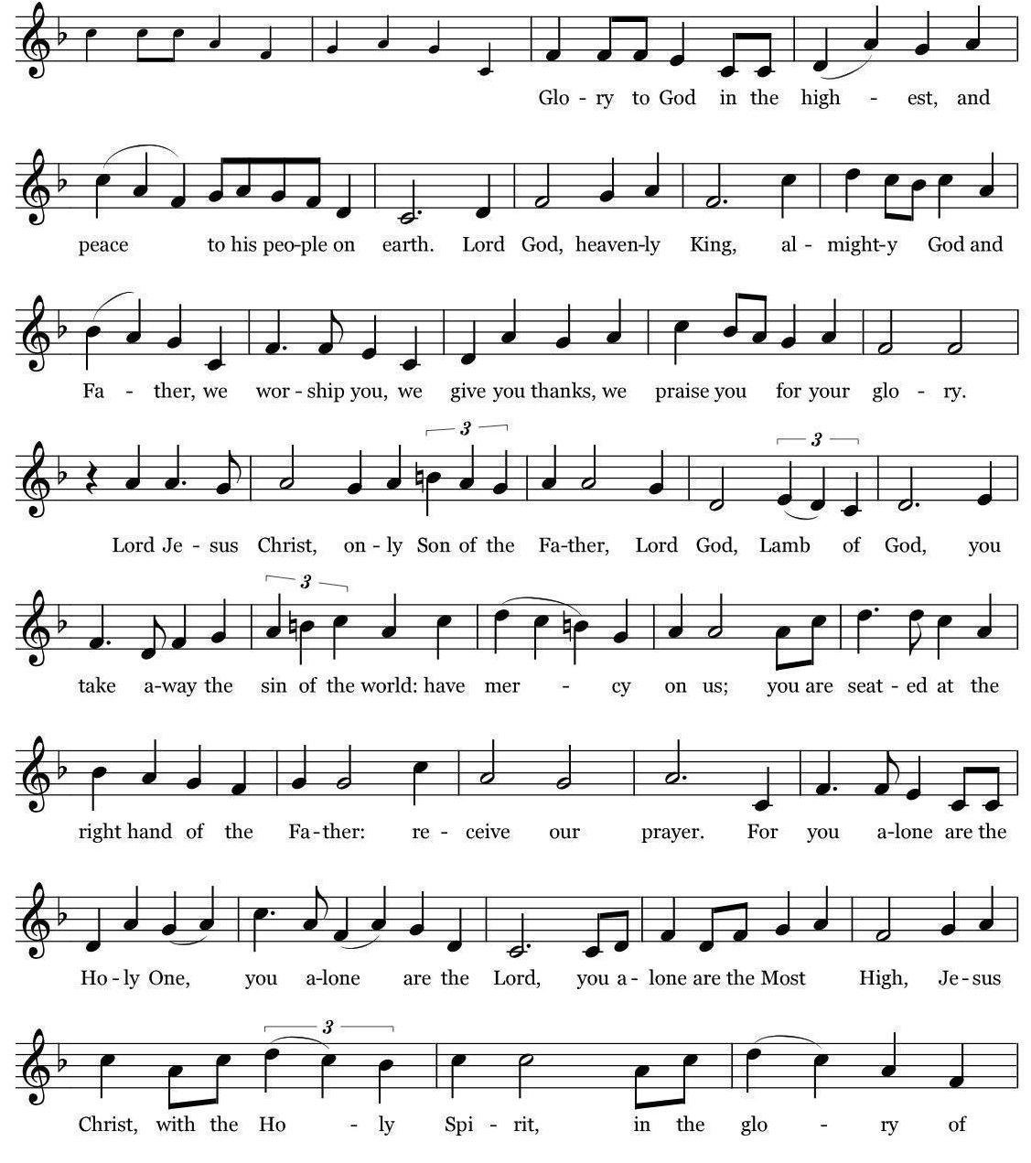
Music: Robert J. Powell © 1985 – Church Publications. All rights reserved. Reprinted under One License.net A700244.

The Collect of the Day

Presider The Lord be with you.
People And also with you.
Presider Let us pray.

O God, you have prepared for those who love you such good things as surpass our understanding: Pour into our hearts such love towards you, that we, loving you in all things and above all things, may obtain your promises, which exceed all that we can desire; through Jesus Christ our Lord, who lives and reigns with you and the Holy Spirit, one God, for ever and ever. Amen.

✠ The people sit.

The First Reading Acts 17:22-31
Reader A Reading from the Book of Acts
Paul stood in front of the Areopagus and said, “Athenians, I see how extremely religious you are in every way. For as I went through the city and looked carefully at the objects of your worship, I found among them an altar with the inscription, ‘To an unknown god.’ What therefore you worship as unknown, this I proclaim to you. The God who made the world and everything in it, he who is Lord of heaven and earth, does not live in shrines made by human hands, nor is he served by human hands, as though he needed anything, since he himself gives to all mortals life and breath and all things. From one ancestor he made all nations to inhabit the whole earth, and he allotted the times of their existence and the boundaries of the places where they would live, so that they would search for God and perhaps grope for him and find him—though indeed he is not far from each one of us. For ‘In him we live and move and have our being’; as even some of your own poets have said, ‘For we too are his offspring.’ Since we are God’s offspring, we ought not to think that the deity is like gold, or silver, or stone, an image formed by the art and imagination of mortals. While God has overlooked the times of human ignorance, now he commands all people everywhere to repent, because he has fixed a day on which he will have the world judged in righteousness by a man whom he has appointed, and of this he has given assurance to all by raising him from the dead.”

Reader The Word of the Lord.
People Thanks be to God.

Psalm 66:7-18 Pg 673 (read responsively by verse)

7 Bless our God, you peoples; *
make the voice of his praise to be heard;

8 Who holds our souls in life, *
and will not allow our feet to slip.

9 For you, O God, have proved us; *
you have tried us just as silver is tried.

10 You brought us into the snare; *
you laid heavy burdens upon our backs.

11 You let enemies ride over our heads; we went through fire and water; *
but you brought us out into a place of refreshment.

12 I will enter your house with burnt-offerings and will pay you my vows, *
which I promised with my lips and spoke with my mouth when I was in trouble.

13 I will offer you sacrifices of fat beasts with the smoke of rams; *
I will give you oxen and goats.

14 Come and listen, all you who fear God, *
and I will tell you what he has done for me.

15 I called out to him with my mouth, *
and his praise was on my tongue.

16 If I had found evil in my heart, *
the Lord would not have heard me;

17 But in truth God has heard me; *
he has attended to the voice of my prayer.

18 Blessed be God, who has not rejected my prayer, *
nor withheld his love from me.

The Second Reading 1 Peter 3:13-22
Reader A Reading from the First Letter of Peter
Now who will harm you if you are eager to do what is good? But even if you do suffer for doing what is right, you are blessed. Do not fear what they fear, and do not be intimidated, but in your hearts sanctify Christ as Lord. Always be ready to make your defense to anyone who demands from you an accounting for the hope that is in you; yet do it with gentleness and reverence. Keep your conscience clear, so that, when you are maligned, those who abuse you for your good conduct in Christ may be put to shame. For it is better to suffer for doing good, if suffering should be God's will, than to suffer for doing evil. For Christ also suffered for sins once for all, the righteous for the unrighteous, in order to bring you to God. He was put to death in the flesh, but made alive in the spirit, in which also he went and made a proclamation to the spirits in prison, who in former times did not obey, when God waited patiently in the days of Noah, during the building of the ark, in which a few, that is, eight persons, were saved through water. And baptism, which this prefigured, now saves you-- not as a removal of dirt from the body, but as an appeal to God for a good conscience, through the resurrection of Jesus Christ, who has gone into heaven and is at the right hand of God, with angels, authorities, and powers made subject to him.

Reader Thanks be to God.

People The Word of the Lord.

✠ The people stand as they are able.

[10:00 service]
Sequence Hymn Shall we gather at the river At the River
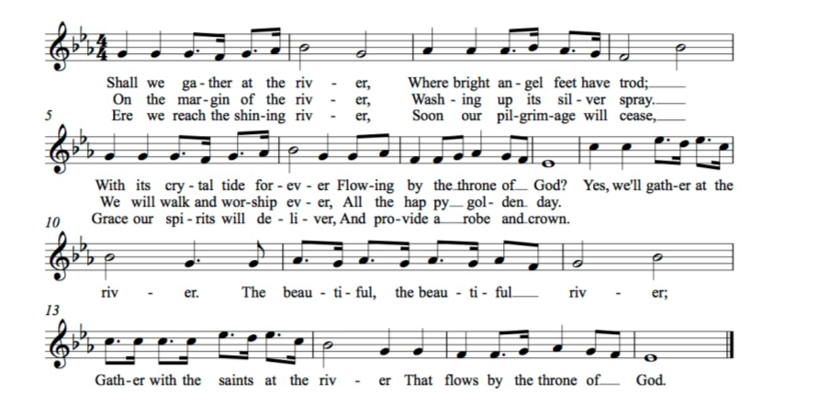

The Gospel John 14:15-21
Gospeler The Holy Gospel of our Lord Jesus Christ according to John
People Glory to you, Lord Christ.
Jesus said, ”If you love me, you will keep my commandments. And I will ask the Father, and he will give you another Advocate, to be with you forever. This is the Spirit of truth, whom the world cannot receive, because it neither sees him nor knows him. You know him, because he abides with you, and he will be in you. ”I will not leave you orphaned; I am coming to you. In a little while the world

will no longer see me, but you will see me; because I live, you also will live. On that day you will know that I am in my Father, and you in me, and I in you. They who have my commandments and keep them are those who love me; and those who love me will be loved by my Father, and I will love them and reveal myself to them.”

Gospeler The Gospel of the Lord.
People Praise to you, Lord Christ.

✠ The people sit.

Sermon The Rev. Mark B. Pendleton

✠ A brief period of silence follows the sermon.

The Nicene Creed (said together)

We believe in one God,
the Father, the Almighty,
maker of heaven and earth,
of all that is, seen and unseen.

We believe in one Lord, Jesus Christ,
the only Son of God,
eternally begotten of the Father,
God from God, Light from Light,
true God from true God,
begotten, not made,
of one Being with the Father.
Through him all things were made.
For us and for our salvation
he came down from heaven:
by the power of the Holy Spirit
he became incarnate from the Virgin Mary,
and was made man.
For our sake he was crucified under Pontius Pilate;
he suffered death and was buried.
On the third day he rose again
in accordance with the Scriptures;
he ascended into heaven
and is seated at the right hand of the Father.
He will come again in glory to judge the living and the dead,
and his kingdom will have no end.
We believe in the Holy Spirit, the Lord, the giver of life,
who proceeds from the Father and the Son.
With the Father and the Son he is worshiped and glorified.
He has spoken through the Prophets.
We believe in one holy catholic and apostolic Church.
We acknowledge one baptism for the forgiveness of sins.
We look for the resurrection of the dead,
and the life of the world to come. Amen.

The Prayers of the People

Lord Christ, you have not left us orphaned, but have given your Church an Advocate. May that same Holy Spirit teach us to keep your commandments and comfort us with divine love.
Silence
We call out to you.
Hear our prayer.

Loving God, bless the suffering. May those who suffer for doing good find a friend in Christ Jesus. May those who suffer from disasters beyond their control find you attentive to the voice of their prayers.
Silence
We call out to you.
Hear our prayer.

Lord of heaven and earth, you made the world and everything in it. You give to all mortals life and breath and all things. May we be faithful stewards of all you have created.
Silence
We call out to you.
Hear our prayer.

Merciful Lord, bless the people of this town and region with a spirit of understanding and peace. May we be set free from fear to live, instead, in hope.
Silence
We call out to you.
Hear our prayer.

God, you are not far from each one of us. You love us as your children. Reveal your love, especially this day, to the sick and sorrowful.

We pray for:

Take a moment, either silently or aloud, to pray for those known to you.

We call out to you.
Hear our prayer.

Heavenly Father, you hold our souls in life. You have saved us in baptism. Because your Son Jesus lives so do we rejoice in the hope of unending life in you.
Silence
We remember those who have died.

Silence

Presider: O Lord our God, accept the fervent prayers of your people; in the multitude of your mercies, look with compassion upon us and all who turn to you for help; for you are gracious, O lover of souls, and to you we give glory, Father, Son, and Holy Spirit, now and for ever. Amen.

✠ The Confession is omitted during the Great Fifty Days of Easter.

The Peace

Presider The peace of the Lord be always with you.
People And also with you.

✠ The people greet one another in the name of the Lord. The Peace may be expressed by shaking hands, bowing, “fist or elbow bumps”, namaste greeting, putting hand over heart, waving, making the peace sign, and by offering a smile.

The Holy Communion

[8:00 service at the Presentation of the Gifts]

Presider All things come of thee, O Lord.
People And of thine own have we given thee. Amen.

[10:00 Service]
Offertory Anthem Locus Iste Anton Bruckner
Christ Church Choir

Translation: This place was made by God, a priceless sacrament it is without reproach.
✠ The people stand for the hymn as they are able.

[10:00 service]
Offertory Hymn 417 This is the feast of the victory for our God Festival Canticle

The Great Thanksgiving

Presider The Lord be with you.
People And also with you.
Presider Lift up your hearts.
People We lift them to the Lord.
Presider Let us give thanks to the Lord our God.
People It is right to give God thanks and praise.

The Presider continues
It is right, and a good and joyful thing, always and everywhere to give thanks to you, Father Almighty, Creator of heaven and earth; but chiefly are we bound to praise you for the glorious resurrection of your Son Jesus Christ our Lord; for he is the true Paschal Lamb, who was sacrificed for us, and has taken away the sin of the world. By his death he has destroyed death, and by his rising to life again he has won for us everlasting life.

Therefore we praise you, joining our voices with Angels and Archangels and with all the company of heaven, who for ever sing this hymn to proclaim the glory of your Name:

[8:00 a.m.] Presider and People
Holy, holy, holy Lord, God of power and might,
heaven and earth are full of your glory.
Hosanna in the highest.
Blessed is the one who comes in the name of the Lord.
Hosanna in the highest.

[10:00 Service] Sanctus S-127
Setting: Calvin Hampton © 1984, 1985, 2010, GIA Publications, Inc. All rights reserved. Reprinted under One License.net A700244.

✠ The people kneel or stand as they are able.

The Presider continues
Holy and gracious Father: In your infinite love you made us for yourself; and, when we had fallen into sin and become subject to evil and death, you, in your mercy, sent Jesus Christ, your only and eternal Son, to share our human nature, to live and die as one of us, to reconcile us to you, the God and Father of all. He stretched out his arms upon the cross, and offered himself in obedience to your will, a perfect sacrifice for the whole world.

On the night he was handed over to suffering and death, our Lord Jesus Christ took bread; and when he had given thanks to you, he broke it, and gave it to his disciples, and said, “Take, eat: This is my Body, which is given for you. Do this for the remembrance of me.”

After supper he took the cup of wine; and when he had given thanks, he gave it to them, and said, “Drink this, all of you: This is my Blood of the new Covenant, which is shed for you and for many for the forgiveness of sins. Whenever you drink it, do this for the remembrance of me.”

Therefore we proclaim the mystery of faith:

Presider and People
Christ has died.
Christ is risen.
Christ will come again.

The Presider continues
We celebrate the memorial of our redemption, O Father, in this sacrifice of praise and thanksgiving. Recalling his death, resurrection, and ascension, we offer you these gifts. Sanctify them by your Holy Spirit to be for your people the Body and Blood of your Son, the holy food and drink of new and unending life in him. Sanctify us also that we may faithfully receive this holy Sacrament, and serve you in unity, constancy, and peace; and at the last day bring us with all your saints into the joy of your eternal kingdom.

All this we ask through your Son Jesus Christ. By him, and with him, and in him, in the unity of the Holy Spirit all honor and glory is yours, Almighty Father, now and for ever. AMEN.

The Presider then continues
And now, as our Savior Christ has taught us, we are bold to say,

People and Presider
Our Father, who art in heaven, hallowed be thy Name, thy kingdom come, thy will be done, on earth as it is in heaven. Give us this day our daily bread. And forgive us our trespasses, as we forgive those who trespass against us. And lead us not into temptation, but deliver us from evil. For thine is the kingdom, and the power, and the glory,
for ever and ever. Amen.

The Breaking of the Bread

✠ A period of silence is kept.

[8:00]
Alleluia. Christ our Passover is sacrificed for us;
Therefore let us keep the feast. Alleluia.

[10:00 service]
Fraction Anthem

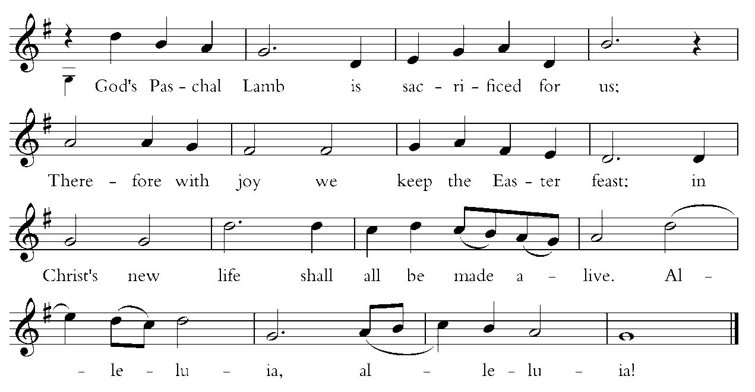
Words by Carl P. Daw, Jr. © 1987, Hope Publishing Company. All rights reserved. Used by permission. One License.net A700244.

Invitation to Communion

The gifts of God for the people of God. Take them in remembrance that Christ died for you, and feed on him in your hearts by faith, with thanksgiving.

Instructions Concerning Communion and Healing

You are invited to receive Holy Communion. Following the usher’s instructions, we begin with those seated in the side sections, starting with the front pews. Please go to the back of the church and proceed down the center aisle to the communion rail. Return to your seat using the outside aisles of those sections. Those seated in the center sections, please come forward beginning with the back pews using the center aisle and return using the diagonal aisles.

Communion may be received kneeling or standing at the altar rails. The bread is received in the open palm. (Gluten-free wafers are available). You may drink from the cup, or place your hand on the base as a sign of devotion. Intinction (dipping the bread/wafer) is not permitted at this time.

Those who do not wish to receive Communion are invited to come forward for a blessing, indicated by crossing your arms over your chest.

Communion can also be brought to you in the pews. Please communicate this request to an usher or the clergy.

The Healing team is available to offer healing prayers at the side of the church. Please tell your healing minister if you have a specific prayer need and if you would like a laying on of hands, just prayers or both.

[10:00 service]
Communion Hymns WLP 765 O blessed spring Berglund 505 O Spirit of Life O heiliger Geist

Post-Communion Prayer

✠ The people kneel or stand as they are able.

Presider and People
Eternal God, heavenly Father,
you have graciously accepted us as living members
of your Son our Savior Jesus Christ,
and you have fed us with spiritual food
in the Sacrament of his Body and Blood.
Send us now into the world in peace,
and grant us strength and courage
to love and serve you
with gladness and singleness of heart;
through Christ our Lord. Amen.

The Blessing

✠ The people stand as they are able.

[10:00 service]
Recessional Hymn 608 Eternal Father, strong to save Melita

The Dismissal

Priest Let us go forth in the name of the Risen Christ. Alleluia! Alleluia!
People Thanks be to God. Alleluia! Alleluia!

[10:00 service] Postlude Trumpet Tune in D major David N. Johnson

The worship is over * The service begins

Participating in Today’s Liturgy:
Preacher/Presider: The Rev. Mark B. Pendleton
Lector at 8:00 a.m.: Fran Hall
Lector at 10:00 a.m.: Lil Walker
Intercessor at 10:00 a.m.:
Eucharistic Minister at 8:00 a.m.: Jeannette McDonald
Eucharistic Minister at 10:00 a.m.: Laurel Patterson
Welcome Team/Usher: Susan Dixo, Tony Santiago
Live Streaming Tech: Joe DiPalermo
Altar Guild: Sue Ingram, Cindy Eaton, Carla Ranks
Hospitality: Jen Murray, Kim Billings, Mary Webber
Flower Delivery: Patti Buck

This week at Christ Church
May 14-20
Sunday | PSP Performance 2:00 p.m. at Exeter High School  PSP Cast Party 5:00 p.m.
Monday | Scouts Parents 6:30 p.m.
Tuesday | Scouts 6:00 p.m.
Wednesday | Oasis Sisters ZOOM Meeting 10:30 a.m.
Thursday | Gentle Yoga 10:00 a.m.
Saturday | YOC 9:00 a.m.  PSP Auditions 1:00 p.m.
Honoring Graduates June 11: IS SOMEONE IN YOUR FAMILY GRADUATING from high school or an institution of higher learning? We would like to list them in the bulletin and celebrate with them on June 11th at the 9:30 a.m. service. Please submit the following form (information) to: Darla at office@christchurchexeter.org Please note that the deadline is June 5. Please share name, name of parents, school or college and degree.

CHRIST CHURCH
43 Pine St., Exeter, NH 03833
Phone: (603) 772-3332 E-mail: office@christchurchexeter.org

Office Hours: Mon, Tue, Thur 9 a.m. - 12 Noon, Weds 9 a.m. - 4 p.m. OFFICE CLOSED FRIDAYS

Rector Ext. 12 [cell phone 860 490-8544]
The Rev. Mark Pendleton mpendleton@christchurchexeter.org

Priest Assoc. for Pastoral care
The Rev. David Holroyd dholroyd@christchurchexeter.org

Priest Associate Ext. 13
The Rev. Melissa Remington mremington@christchurchexeter.org

Interim Director of Music
Suzanne Jalbert Jones musicdirector@christchurchexeter.org

Organist
Bruce Adami bruce@christchurchexeter.org

Administrative assistant Ext. 11
Darla Watt office@christchurchexeter.org

Bookkeeper
Jeannie Madley bookkeeper@christchurch.org

Senior Sexton
George Malgeri ssexton@christchurchexeter.org

Artistic Director of Pine Street Players
Lexi Meunier thepinestreetplayers@gmail.com

Events Coordinator
Christina DeMaio events@christchurchexeter.org

Vestry

Senior Warden Patricia Gianotti
Junior Warden Judy Blaisdell Treasurer Richard Ingram
Clerk John Cofer

Lauri Ayers John Hodsdon Susan Dixon
Christopher Sera Jennifer Murray John Woodard
Morgan McCay Alice Bentley

