CHRIST CHURCH
of Exeter

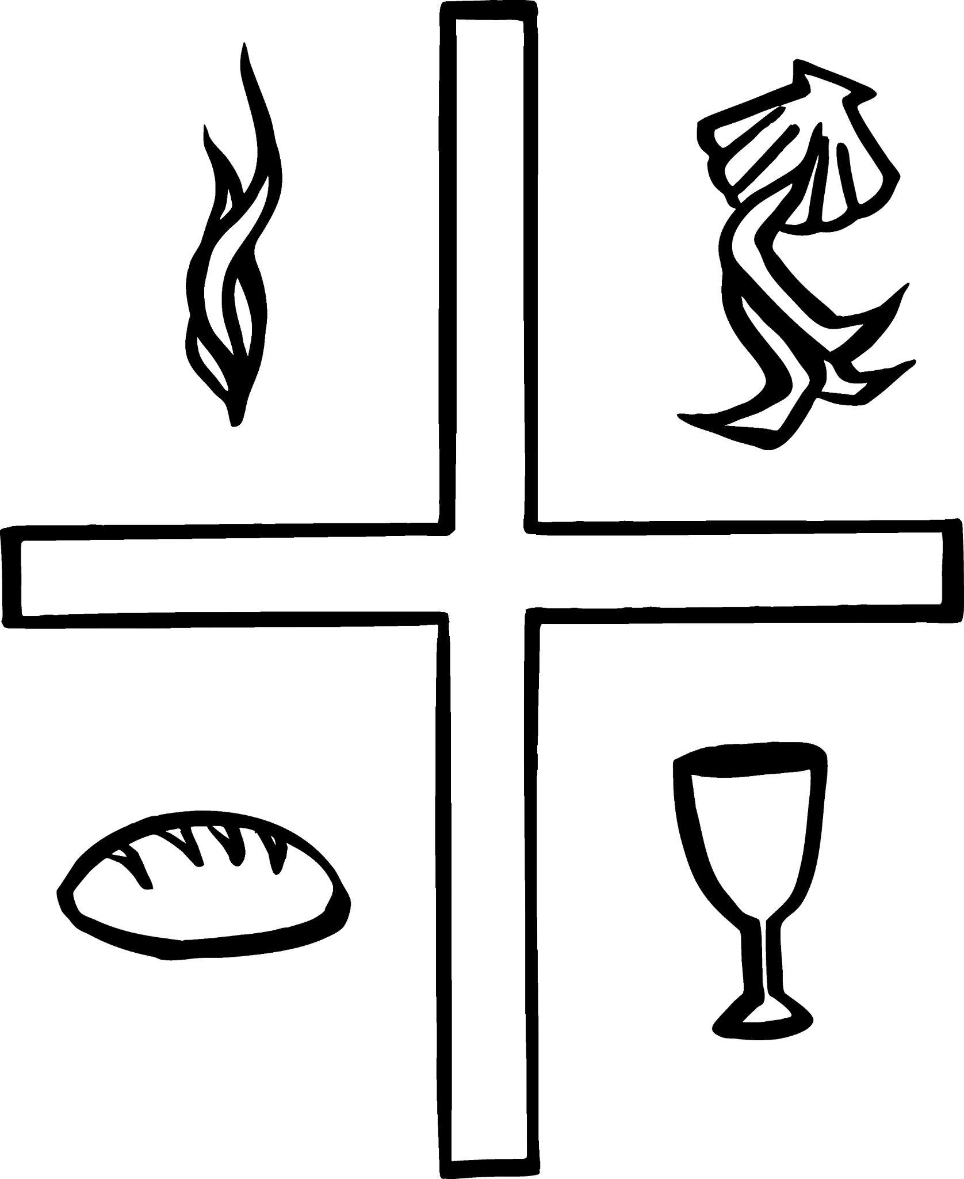

Live
joyfully in faith

Connect
with God and one another

Serve
the local and global community

The Seventh Sunday of Easter
May 21, 2023
8:00 & 10:00 a.m.

Reflections on Today’s Readings

We begin today the final week of Easter. Last Thursday we celebrated Jesus’ ascension to the Father and his glorification. The Gospel reading today is a portion of the prayer he prayed on the night before his death, in which he consecrated his offering of himself to God, and prayed for us that we might be made part of his offering. In baptism we have, in fact, received the benefits of that prayer.

The reading from the Acts of the Apostles is the beginning of that book. Luke describes Jesus’ ascension and the promise that he would shortly empower his friends with the Holy Spirit. We\ are told that the disciples, including Jesus’ mother, then spent the remaining days together in prayer waiting for that gift of the Spirit, which would come upon them on the Day of Pentecost.

In the passage from 1 Peter, we are exhorted to live lives in keeping with our vocation given in baptism. If we are to suffer, let it be for doing good, not because of wrongdoing. Such righteous suffering deepens our union with Christ. We are already assured by Jesus’
resurrection that no suffering can destroy the eternal life we have been given.

We gather week by week to celebrate the Eucharist. The Ascension reminds us that in the Eucharist Jesus is not made present by being brought down to us; he is present because in the Eucharist we are taken up to where he is. For a moment, we are not only in the world but we become citizens of the eternal Kingdom.

From The Rite Light: Reflections on the Sunday Readings and Seasons of the Church Year. Copyright © 2009 by Michael W. Merriman. Church Publishing Incorporated, New York.

Welcome to Christ Church: If you are visiting for the first time, please fill out the welcome cards in the pews and hand it to a member of the clergy after the service. Books and resources for children are located on the table near the side left door. Although there are customary postures (such as standing and kneeling) in Episcopal worship, you are invited to be seated at any point, according to your needs and comfort.

Communion: We offer communion in one kind. It should be understood that communion in one kind (bread/wafer only) is sufficient to experience the Real Presence of our Risen Lord.

The Holy Eucharist

[10:00 service]
Prelude Air from Suite in D J. S. Bach

Welcome

[10:00 service]
Processional Hymn 214 Hail the day that sees him rise Llanfair

Presider Alleluia. Christ is risen.
People The Lord is risen indeed. Alleluia.

Presider and People: Almighty God, to you all hearts are open, all desires known, and from you no secrets are hid: Cleanse the thoughts of our hearts by the inspiration of your Holy Spirit, that we may perfectly love you, and worthily magnify your holy Name; through Christ our Lord. Amen.
[8:00 service]

Glory to God in the highest,
and peace to his people on earth.

Lord God, heavenly King,
almighty God and Father,
we worship you, we give you thanks,
we praise you for your glory.

Lord Jesus Christ, only Son of the Father,
Lord God, Lamb of God,
you take away the sin of the world:
have mercy on us;
you are seated at the right hand of the Father:
receive our prayer.

For you alone are the Holy One,
you alone are the Lord,
you alone are the Most High,
Jesus Christ,
with the Holy Spirit,
in the glory of God the Father. Amen.

[10:00 service] Gloria S-280

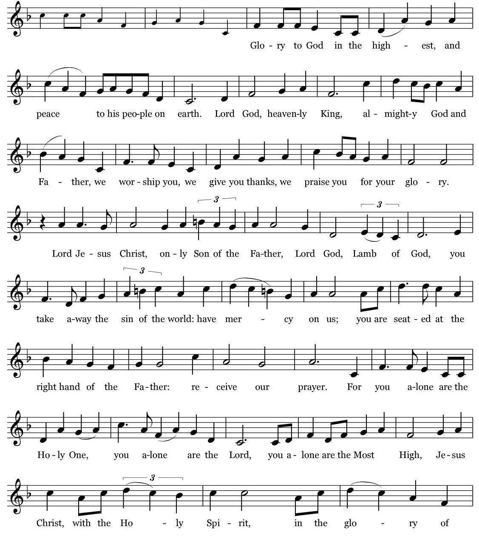
Music: Robert J. Powell © 1985 – Church Publications. All rights reserved. Reprinted under One License.net A700244.

The Collect of the Day

Presider The Lord be with you.
People And also with you.
Presider Let us pray.

O God, the King of glory, you have exalted your only Son Jesus Christ with great triumph to your kingdom in heaven: Do not leave us comfortless, but send us your Holy Spirit to strengthen us, and exalt us to that place where our Savior Christ has gone before; who lives and reigns with you and the Holy Spirit, one God, in glory everlasting. Amen.

✠ The people sit.

The First Reading Acts 1:6-14
Reader A Reading from the Book of Acts
When the apostles had come together, they asked Jesus, “Lord, is this the time when you will restore the kingdom to Israel?” He replied, “It is not for you to know the times or periods that the Father has set by his own authority. But you will receive power when the Holy Spirit has come upon you; and you will be my witnesses in Jerusalem, in all Judea and Samaria, and to the ends of the earth.” When he had said this, as they were watching, he was lifted up, and a cloud took him out of their sight. While he was going and they were gazing up toward heaven, suddenly two men in white robes stood by them. They said, “Men of Galilee, why do you stand looking up toward
heaven? This Jesus, who has been taken up
from you into heaven, will come in the same way as you saw him go into heaven.” Then they returned to Jerusalem from the mount called Olivet, which is near Jerusalem, a sabbath day’s journey away. When they had entered the city, they went to the room upstairs where they were staying, Peter, and John, and James, and Andrew, Philip and Thomas, Bartholomew and Matthew, James son of Alphaeus, and Simon the Zealot, and Judas son of James. All these were constantly devoting themselves to prayer, together with certain women, including Mary the mother of Jesus, as well as his brothers.

Reader The Word of the Lord.
People Thanks be to God.

Psalm 68:1-10, 33-36 Pg 676 (read responsively by verse)

1 Let God arise, and let his enemies be scattered; *
let those who hate him flee before him.

2 Let them vanish like smoke when the wind drives it away; *
as the wax melts at the fire, so let the wicked perish at the presence of God.

3 But let the righteous be glad and rejoice before God; *
let them also be merry and joyful.

4 Sing to God, sing praises to his Name; exalt him who rides upon the heavens; *
YAHWEH is his Name, rejoice before him!

5 Father of orphans, defender of widows, *
God in his holy habitation!

6 God gives the solitary a home and brings forth prisoners into freedom; *
but the rebels shall live in dry places.

7 God, when you went forth before your people, *
when you marched through the wilderness,

8 The earth shook, and the skies poured down rain,
at the presence of God, the God of Sinai, *
at the presence of God, the God of Israel.

9 You sent a gracious rain, O God, upon your inheritance; *
you refreshed the land when it was weary.

10 Your people found their home in it; *
in your goodness, O God, you have made provision for the poor.

33 Sing to God, O kingdoms of the earth; *
sing praises to the Lord.

34 He rides in the heavens, the ancient heavens; *
he sends forth his voice, his mighty voice.

35 Ascribe power to God; *
his majesty is over Israel; his strength is in the skies.

36 How wonderful is God in his holy places! *
the God of Israel giving strength and power to his people! Blessed be God!

The Second Reading 1 Peter 4:12-14, 5:6-11
Reader A Reading from the First Letter of Peter
Beloved, do not be surprised at the fiery ordeal that is taking place among you to test you, as though something strange were happening to you. But rejoice insofar as you are sharing Christ's sufferings, so that you may also be glad and shout for joy when his glory is revealed. If you are reviled for the name of Christ, you are blessed, because the spirit of glory, which is the Spirit of God, is resting on you. Humble yourselves therefore under the mighty hand of God, so that he may exalt you in due time. Cast all your anxiety on him,
because he cares for you. Discipline

Reader The Word of the Lord.
yourselves, keep alert. Like a roaring lion your
adversary the devil prowls around, looking for someone to devour. Resist him, steadfast in your faith, for you know that your brothers and sisters in all the world are undergoing the same kinds of suffering. And after you have suffered for a little while, the God of all grace, who has called you to his eternal glory in Christ, will himself restore, support, strengthen, and establish you. To him be the power forever and ever. Amen.

Reader Thanks be to God.

✠ The people stand as they are able.

[10:00 service]
Sequence Hymn 613, vv. 1-2 Thy kingdom come, O God! St. Cecilia
The Gospel John 17:1-11
Gospeler The Holy Gospel of our Lord Jesus Christ according to John
People Glory to you, Lord Christ.
Jesus looked up to heaven and said, “Father, the hour has come; glorify your Son so that the Son may glorify you, since you have given him authority over all people, to give eternal life to all whom you have given him. And this is eternal life, that they may know you, the only true God, and Jesus Christ whom you have sent. I glorified you on earth by finishing the work that you gave me to do. So now, Father, glorify me in your own presence with the glory that I had in your presence before the world existed. ”I have made your name known to those whom you gave me from the world. They were yours, and you gave them to me, and they have kept your word. Now they know that everything you have given me is from you; for the words that you gave to me I have given to them, and they have received them and know in truth that I came from you; and they have believed that you sent me. I am asking on their behalf; I am not asking on behalf of the world, but on behalf of those whom you gave me, because they are yours. All mine are yours, and yours are mine; and I have been glorified in them. And now I am no longer in the world, but they are in the world, and I am coming to you. Holy Father, protect them in your name that you have given me, so that they may be one, as we are one.”

Gospeler The Gospel of the Lord.
People Praise to you, Lord Christ.

✠ The people sit.

Sermon The Rev. Mark B. Pendleton

✠ A brief period of silence follows the sermon.

The Nicene Creed (said together)

We believe in one God,
the Father, the Almighty,
maker of heaven and earth,
of all that is, seen and unseen.

We believe in one Lord, Jesus Christ,
the only Son of God,
eternally begotten of the Father,
God from God, Light from Light,
true God from true God,
begotten, not made,
of one Being with the Father.
Through him all things were made.
For us and for our salvation
he came down from heaven:
by the power of the Holy Spirit
he became incarnate from the Virgin Mary,
and was made man.
For our sake he was crucified under Pontius Pilate;
he suffered death and was buried.
On the third day he rose again
in accordance with the Scriptures;
he ascended into heaven
and is seated at the right hand of the Father.
He will come again in glory to judge the living and the dead,
and his kingdom will have no end.
We believe in the Holy Spirit, the Lord, the giver of life,
who proceeds from the Father and the Son.
With the Father and the Son he is worshiped and glorified.
He has spoken through the Prophets.
We believe in one holy catholic and apostolic Church.
We acknowledge one baptism for the forgiveness of sins.
We look for the resurrection of the dead,
and the life of the world to come. Amen.

The Prayers of the People

I ask your prayers for God's people throughout the world; for Michael our Presiding Bishop and Rob our Bishop; for this gathering; and for all ministers and people.

Pray for the Church.

Silence

I ask your prayers for peace; for goodwill among nations; and for the well-being of all people.

Pray for justice and peace.

Silence

I ask your prayers for the poor, the sick, the hungry, the oppressed, and those in prison.

Pray for those in any need or trouble.

Silence

I ask your prayers for all who seek God, or a deeper knowledge of God.

Pray that they may find and be found by God.

Silence

I ask your prayers for the departed. Pray for those who have died.

Silence

We remember Sara Miller Codding in whose memory the Altar Flowers are given. .

Silence

Praise God for those in every generation in whom Christ has been honored. Pray that we may have grace to glorify Christ in our own day.

Silence

Presider: O Lord our God, accept the fervent prayers of your people; in the multitude of your mercies, look with compassion upon us and all who turn to you for help; for you are gracious, O lover of souls, and to you we give glory, Father, Son, and Holy Spirit, now and for ever. Amen.

✠ The Confession is omitted during the Great Fifty Days of Easter.

The Peace

Presider The peace of the Lord be always with you.
People And also with you.

✠ The people greet one another in the name of the Lord. The Peace may be expressed by shaking hands, bowing, “fist or elbow bumps”, namaste greeting, putting hand over heart, waving, making the peace sign, and by offering a smile.

The Holy Communion

[8:00 service at the Presentation of the Gifts]

Presider All things come of thee, O Lord.
People And of thine own have we given thee. Amen.

[10:00 Service]
Offertory Anthem A Gaelic Blessing John Rutter
Christ Church Choir

Deep peace of the running wave to you, Deep peace of the flowing air to you,
Deep peace of the quiet earth to you, Deep peace of the shining stars to you,
Deep peace of the gentle night to you, Moon and stars pour their healing light on you,
Deep peace of Christ the light of the world to you.

✠ The people stand for the hymn as they are able.

[10:00 service]
Offertory Hymn 215 See the Conqueror mounts in triumph In Babilone

The Great Thanksgiving

Presider The Lord be with you.
People And also with you.
Presider Lift up your hearts.
People We lift them to the Lord.
Presider Let us give thanks to the Lord our God.
People It is right to give God thanks and praise.

The Presider continues
It is right, and a good and joyful thing, always and everywhere to give thanks to you, Father Almighty, Creator of heaven and earth; Through your dearly beloved Son Jesus Christ our Lord.
After his glorious resurrection he openly appeared to his disciples, and in their sight ascended into heaven, to prepare a place for us; that where he is, there we might also be, and reign with him in glory.

Therefore we praise you, joining our voices with Angels and Archangels and with all the company of heaven, who for ever sing this hymn to proclaim the glory of your Name:

[8:00 a.m.] Presider and People
Holy, holy, holy Lord, God of power and might,
heaven and earth are full of your glory.
Hosanna in the highest.
Blessed is the one who comes in the name of the Lord.
Hosanna in the highest.

[10:00 Service] Sanctus S-127
Setting: Calvin Hampton © 1984, 1985, 2010, GIA Publications, Inc. All rights reserved. Reprinted under One License.net A700244.

✠ The people kneel or stand as they are able.

The Presider continues
Holy and gracious Father: In your infinite love you made us for yourself; and, when we had fallen into sin and become subject to evil and death, you, in your mercy, sent Jesus Christ, your only and eternal Son, to share our human nature, to live and die as one of us, to reconcile us to you, the God and Father of all. He stretched out his arms upon the cross, and offered himself in obedience to your will, a perfect sacrifice for the whole world.

On the night he was handed over to suffering and death, our Lord Jesus Christ took bread; and when he had given thanks to you, he broke it, and gave it to his disciples, and said, “Take, eat: This is my Body, which is given for you. Do this for the remembrance of me.”

After supper he took the cup of wine; and when he had given thanks, he gave it to them, and said, “Drink this, all of you: This is my Blood of the new Covenant, which is shed for you and for many for the forgiveness of sins. Whenever you drink it, do this for the remembrance of me.”

Therefore we proclaim the mystery of faith:

Presider and People
Christ has died.
Christ is risen.
Christ will come again.

The Presider continues
We celebrate the memorial of our redemption, O Father, in this sacrifice of praise and thanksgiving. Recalling his death, resurrection, and ascension, we offer you these gifts. Sanctify them by your Holy Spirit to be for your people the Body and Blood of your Son, the holy food and drink of new and unending life in him. Sanctify us also that we may faithfully receive this holy Sacrament, and serve you in unity, constancy, and peace; and at the last day bring us with all your saints into the joy of your eternal kingdom.

All this we ask through your Son Jesus Christ. By him, and with him, and in him, in the unity of the Holy Spirit all honor and glory is yours, Almighty Father, now and for ever. AMEN.

The Presider then continues
And now, as our Savior Christ has taught us, we are bold to say,

People and Presider
Our Father, who art in heaven, hallowed be thy Name, thy kingdom come, thy will be done, on earth as it is in heaven. Give us this day our daily bread. And forgive us our trespasses, as we forgive those who trespass against us. And lead us not into temptation, but deliver us from evil. For thine is the kingdom, and the power, and the glory,
for ever and ever. Amen.

The Breaking of the Bread

✠ A period of silence is kept.

[8:00]
Alleluia. Christ our Passover is sacrificed for us;
Therefore let us keep the feast. Alleluia.

[10:00 service]
Fraction Anthem

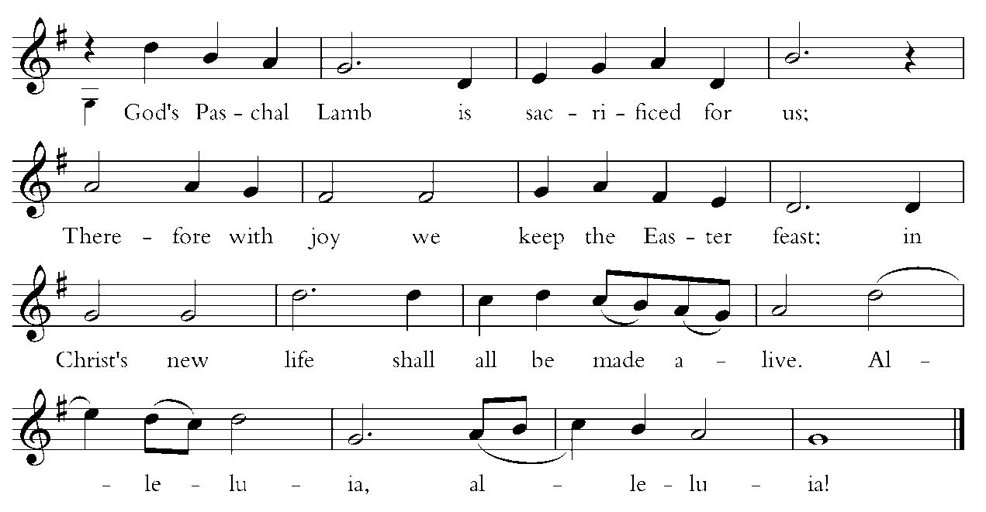
Words by Carl P. Daw, Jr. © 1987, Hope Publishing Company. All rights reserved. Used by permission. One License.net A700244.

Invitation to Communion

The gifts of God for the people of God. Take them in remembrance that Christ died for you, and feed on him in your hearts by faith, with thanksgiving.

Instructions Concerning Communion and Healing

You are invited to receive Holy Communion. Following the usher’s instructions, we begin with those seated in the side sections, starting with the front pews. Please go to the back of the church and proceed down the center aisle to the communion rail. Return to your seat using the outside aisles of those sections. Those seated in the center sections, please come forward beginning with the back pews using the center aisle and return using the diagonal aisles.

Communion may be received kneeling or standing at the altar rails. The bread is received in the open palm. (Gluten-free wafers are available). You may drink from the cup, or place your hand on the base as a sign of devotion. Intinction (dipping the bread/wafer) is not permitted at this time.

Those who do not wish to receive Communion are invited to come forward for a blessing, indicated by crossing your arms over your chest.

Communion can also be brought to you in the pews. Please communicate this request to an usher or the clergy.

The Healing team is available to offer healing prayers at the side of the church. Please tell your healing minister if you have a specific prayer need and if you would like a laying on of hands, just prayers or both.

[10:00 service]
Communion Hymn 693 Just as I am, without one plea Woodworth
Post-Communion Prayer

✠ The people kneel or stand as they are able.

Presider and People
Eternal God, heavenly Father,
you have graciously accepted us as living members
of your Son our Savior Jesus Christ,
and you have fed us with spiritual food
in the Sacrament of his Body and Blood.
Send us now into the world in peace,
and grant us strength and courage
to love and serve you
with gladness and singleness of heart;
through Christ our Lord. Amen.

The Blessing

✠ The people stand as they are able.

[10:00 service]
Recessional Hymn Rejoice the Lord is King! Darwall’s 148th
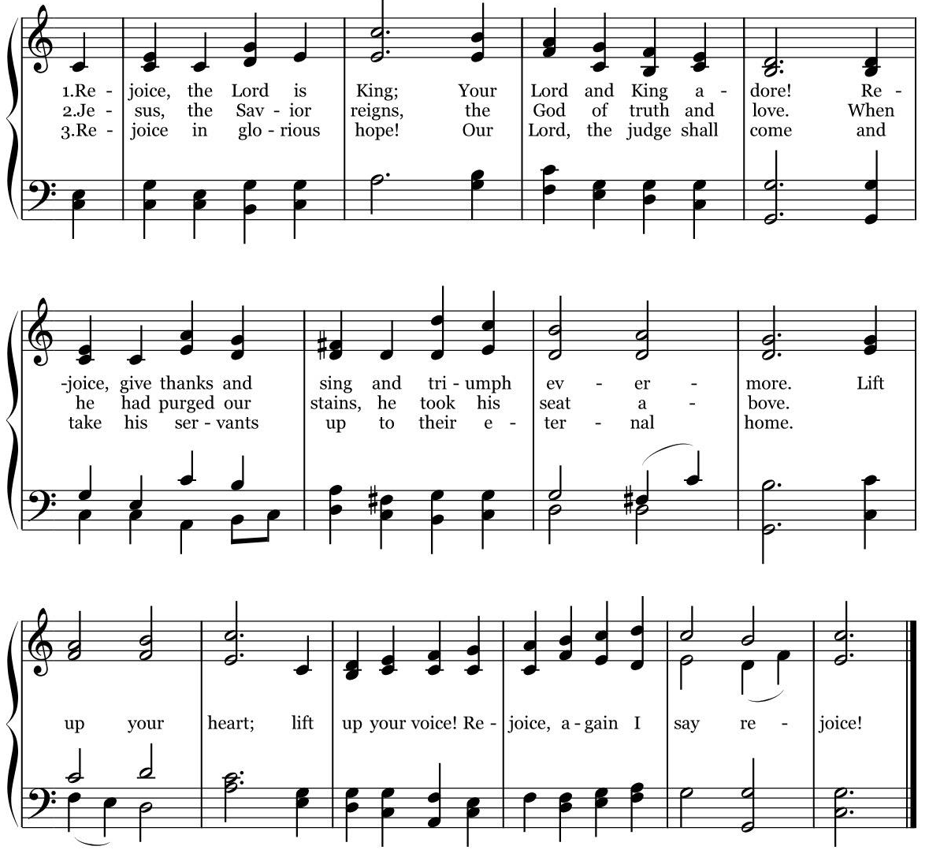

The Dismissal

Priest Let us go forth in the name of the Risen Christ. Alleluia! Alleluia!
People Thanks be to God. Alleluia! Alleluia!

[10:00 service]
Postlude Paraphrase on “Thine is the Glory” Alexandre Guilmant

The worship is over * The service begins

Participating in Today’s Liturgy:
Preacher/Presider: The Rev. Mark B. Pendleton
Lector at 8:00 a.m.: Lee Woodworth
Lector at 10:00 a.m.: Susan Dixon
Intercessor at 10:00 a.m.:
Eucharistic Minister at 8:00 a.m.:
Eucharistic Minister at 10:00 a.m.: Carol Allard
Welcome Team/Usher: Scott Anders
Live Streaming Tech: Will Sera
Altar Guild: Melissa Poirier, Robin Sirois
Hospitality: Suzanne Fong, Linzee Coleman-Bagge
Altar Flowers: The flowers are given in memory of Sara Miller Codding by Anthony Codding, Anthony Codding, Jr., and Elizabeth Codding.
Flower Delivery: Carol Allard

This week at Christ Church
May 21 - 27
Sunday
Tuesday | Bible Study 11:00 a.m.  PSP Rehearsal 6:00 p.m.  Scouts 6:00 p.m.
Wednesday | Oasis Sisters ZOOM Meeting 10:30 a.m.  PSP Rehearsal 4:00 p.m.
Thursday | Gentle Yoga 10:00 a.m.

Honoring Graduates June 11: IS SOMEONE IN YOUR FAMILY GRADUATING from high school or an institution of higher learning? We would like to list them in the bulletin and celebrate with them on June 11th at the 9:30 a.m. service. Please submit the following form (information) to: Darla at office@christchurchexeter.org Please note that the deadline is June 5. Please share name, name of parents, school or college and degree.

CHRIST CHURCH
43 Pine St., Exeter, NH 03833
Phone: (603) 772-3332 E-mail: office@christchurchexeter.org

Office Hours: Mon, Tue, Thur 9 a.m. - 12 Noon, Weds 9 a.m. - 4 p.m. OFFICE CLOSED FRIDAYS

Rector Ext. 12 [cell phone 860 490-8544]
The Rev. Mark Pendleton mpendleton@christchurchexeter.org

Priest Assoc. for Pastoral care
The Rev. David Holroyd dholroyd@christchurchexeter.org

Priest Associate Ext. 13
The Rev. Melissa Remington mremington@christchurchexeter.org

Interim Director of Music
Suzanne Jalbert Jones musicdirector@christchurchexeter.org

Organist
Bruce Adami bruce@christchurchexeter.org

Administrative assistant Ext. 11
Darla Watt office@christchurchexeter.org

Bookkeeper
Jeannie Madley bookkeeper@christchurch.org

Senior Sexton
George Malgeri ssexton@christchurchexeter.org

Artistic Director of Pine Street Players
Lexi Meunier thepinestreetplayers@gmail.com

Events Coordinator
Christina DeMaio events@christchurchexeter.org

Vestry

Senior Warden Patricia Gianotti
Junior Warden Judy Blaisdell Treasurer Richard Ingram
Clerk John Cofer

Lauri Ayers John Hodsdon Susan Dixon
Christopher Sera Jennifer Murray John Woodard
Morgan McCay Alice Bentley

